Tips for supporting your child through the Corona Virus pandemic
As we enter this period of uncertainty, the following may be helpful:

Take care of yourself

This is important as you will need to be as resilient as possible to support your child.

Talk to your child

Use age-appropriate language to talk to your child.
Social stories can be helpful. Here are a few examples:
https://www.ppmd.org/wp-content/uploads/2020/03/The-Corona-Virus-Free-Printable-Updated-2-The-Autism-Educator-.pdf

https://paautism.org/resource/coronavirus-social-story/

Create a new ‘normal’

Predictability and routine is known to be helpful, and it can be tricky without school to structure the day. It might help to make a daily schedule while schools are closed so that children know what will happen during the day and when it will happen. Making this visual by using pictures, lists, traditional timetables etc. can help.
If there is more than one child in the house, do a timetable for each day for each person which includes together time, outside time, alone time (where appropriate) and one to one time. 1:1 time could be linked to household tasks such as cooking. If adults have a timetable as well, it helps children see what parents have to do too. You can also use things to give structure, such as, for example, instead of having all toys available, having a box of 'today's special' which keeps things interesting, or you can set things out so that it shows what needs to be done, or give someone a list of things to get out ready for making tea. You can also put a surprise icon on the timetable and introduce something as a treat which prevents things being too predictable. Having goals and keeping a record of what is achieved can give purpose and satisfaction.
Creating the next day's timetable can be an activity!

Be aware of sensory components

Some children might have sensitivities around soaps and hand washes, managing bodily fluids, uncomfortable bodily sensations and changes in taste and smell when ill. Be aware that for some, noises and lights can be overwhelming and can raise stress levels. Children may need time alone or in quiet/darkened spaces. Creating a calming area that a child can retreat to might be helpful. There are some useful ideas
https://www.autismparentingmagazine.com/creating-sensory-space-for-asd-kids/

Understand anxiety

Your child might, understandably, feel more anxious than usual but may struggle to communicate this. If behaviour becomes more challenging to you than usual, bear in mind that it may well be related to increased stress. Using sensory approaches, distraction and increased structure can help.

Also, don’t forget you need to look after yourself. There are some tips and ideas to help you as parents too:
https://www.psycom.net/coping-with-stress-while-caring-for-a-child-with-autism/

Make the most of strong interests

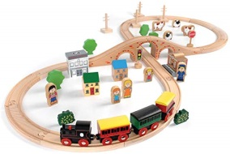
Your child’s interests have a number of positive benefits:
Emotional regulation
Being absorbed in something is a really good way of taking our minds off things that are worrying us. Allowing your child to lose themselves in their interest could help with emotional regulation.
Diverting
Strong interests can be used to distract and divert when this is needed.
Occupying
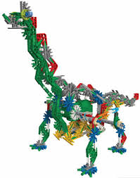
Your child might be happy to spend additional time on things if they are related to their special interest. You could do a project based around it, e.g. make a scrap book; make models; create art work; research on the internet; take virtual tours; write about it; make videos or animations.
Be mindful, however, to still put limits around this so that it does not get in the way of other things that your child needs to do.

Additional information
https://youngminds.org.uk/
https://www.mymind.org.uk/

https://chatterpack.net/blogs/blog/resources-list-for-home-learning

