

**Wargrave House**

**The Autism Specialists**

**Child Protection &**

**Safeguarding Children Policy**

September 2019

|  |  |
| --- | --- |
| **Reviewer:** | Stuart Jamieson (HOE/DSL) |
| **Co-Reviewer:** | Chris Powell ( Care Manager) |
| **Updated:** | September 2019 |
| **Next Review:** | September 2020 |
| **Committee:** | Personal Development, Behaviour and Attitudes |
| **Approved by the full Governing Body:** | 31st March 2020 |

|  |  |
| --- | --- |
| **This policy should be read in conjunction with the following policies:** | |
| 1 | Safeguarding Adults Policy |
| 2 | The Prevent Duty |
| 3 | Recruitment & Selection of Staff |
| 4 | Positive Planning for Supporting Student Behaviour |
| 5 | Anti-Bullying Policy Statement |
| 6 | Health & Safety (including Lone Workers Policy) |
| 7 | Curriculum Statement (includes Sex & Relationships Education Policy & Guidelines) |
| 8 | Partnership with Parents Policy |
| 9 | School as a Community: Objectives on Communication |
| 10 | Visitors to Wargrave House Policy |
| 11 | The Acceptable Use of Information Technology Policy |
| 12 | Mobile Phones Policy |
| 13 | Staff Grievance & Disciplinary Procedure |
| 14 | Whistle Blowing Policy |
| 15 | Intimate Care Policy |
| 16 | DBS Policy |
| 17 | Equal Opportunities Statement & Policy |
| 18 | Admissions, Discharges, Attendance and Review Procedures |
| 19 | Whole Staff Behaviour Policy (Code of Conduct) |
| 20 | Safe Storage and Administration of Medication |
| 21 | Complaints Policy |
| 22 | Data Control Policy including GDPR Policy |

|  |  |
| --- | --- |
| **Contents** | |
|  | Page |
| 1. Introduction | 4 |
|  |  |
| 2. Purpose | 4 |
|  |  |
| 3. Aims | 5 |
|  |  |
| 4. Roles and Responsibilities | 5 |
|  |  |
| 5. Policy | 8 |
|  |  |
| 6. Procedure | 17 |
|  |  |
| 7. Legal Context | 22 |
|  |  |
| **References & Further Resources** |  |
| 1. Signs & Symptoms of Abuse | 26 |
| 1. Directory of Address & Telephone Numbers | 34 |
| 1. Useful Resources | 35 |
| 1. Summary of the UN Convention on the rights of the child | 40 |
| 1. European Charter for Persons with Autism | 41 |
| **Appendices** |  |
| 1. Female Genital Mutilation (FGM) Mandatory Reporting Duty | 43 |
| 1. Types of Abuse and Neglect | 44 |
| 1. Cause for Concern forms | 46 |
| 1. (a) Actions where there are concerns about a child | 48 |
| (b) St Helens LSCB Reporting Procedure | 49 |
| 1. St Helens Children & Young Peoples Service Request form | 50 |
| 1. Welfare Log | 54 |
| 1. (a) Safeguarding File Transfer Record & Receipt form | 57 |
| (b) Safeguarding File Transfer letter | 58 |
| 1. Operation Encompass report form | 59 |
| 1. Record of Authorised Student Search | 60 |
| 1. Flowchart for the initial management of allegations about staff | 61 |
| 1. Thee Seven Golden Rules to Sharing Information | 62 |

1. **Introduction**
   1. Wargrave House Limited is committed to safeguarding and promoting the welfare of all students.

Safeguarding and promoting the welfare of children is defined for the purposes of this policy as:

* Protecting children from maltreatment;
* Preventing impairment of children’s health or development;
* Ensuring that children grow up in circumstances consistent with the provision of safe and effective care; and
* Taking action to enable all children to have the best outcomes.

*Working Together to Safeguard Children (2018) pages 6-7*

1.2 All Wargrave House staff are well placed to observe the outward signs of abuse through their day to day contact with students. However, when such contact exists, opportunities for abuse to take place and for allegations of abuse, whether these be false, malicious or misplaced, also exist. We recognise that high self-esteem, confidence, supportive friends and clear lines of communication with a trusted adult helps all children, and especially those at risk of, or suffering from, abuse. Wargrave House will therefore:

* Establish and maintain an environment where students feel secure, are encouraged to communicate and are listened to, taking into account the needs of children and young people with Autistic Spectrum Disorders (ASD).
* Ensure that students know that there are adults in school and college whom they can approach if they are worried or in difficulty.
* Include opportunities in the Personal, Social, Health and Economic Education (PSHEE) curriculum for students to develop the skills they need to recognise and stay safe from abuse.
* Develop and implement policies relating to practice and procedures on the management of such issues.
* Ensure that wherever possible every effort will be made to establish effective working relationships with parents and colleagues from other agencies.
* Foster a culture of openness and integrity in line with the company’s Whistle Blowing Policy.

1. **Purpose**

2.1 Wargrave House fully recognises the contribution it can make to protect children from harm. The purpose of this policy is to outline the duty and responsibilities of staff, volunteers, governors and trustees (hereafter collectively referred to as the ‘workforce’) working on behalf of Wargrave House Limited.

This policy is based on the following statutory guidance.

[Keeping Children Safe in Education (2019)](https://www.gov.uk/government/publications/keeping-children-safe-in-education--2) and [Working Together to Safeguard Children (2018)](https://www.gov.uk/government/publications/working-together-to-safeguard-children--2), and the [Governance Handbook](https://www.gov.uk/government/publications/governance-handbook). We comply with this guidance and the arrangements agreed and published by our 3 local safeguarding partners.

This policy is also based on the following legislation:

Part 1 of the schedule to the [Non-Maintained Special Schools (England) Regulations 2015](http://www.legislation.gov.uk/uksi/2015/728/schedule/made), which places a duty on non-maintained special schools to safeguard and promote the welfare of pupils at the school

The [Childcare (Disqualification) and Childcare (Early Years Provision Free of Charge) (Extended Entitlement) (Amendment) Regulations 2018](http://www.legislation.gov.uk/uksi/2018/794/contents/made) (referred to in this policy as the “2018 Childcare Disqualification Regulations”) and [Childcare Act 2006](http://www.legislation.gov.uk/ukpga/2006/21/contents), which set out who is disqualified from working with children

2.2 The company’s policy on Safeguarding Children serves to:

* Safeguard the welfare of children.
* Provide a secure framework for staff to work within.
* Set out clearly the responsibilities of all adults working within the school and equip them with the skills to identify concerns early, provide help for children, and prevent concerns from escalating.
* Support the ethos of the company.
* Explain how the company will respond to relevant legislation and practice issues.

The student’s welfare is of paramount importance and Wargrave House will always act in the best interests of the child.

**3. Aim(s):**

3.1 The aim of this policy is to safeguard and promote student’s welfare, safety, health and guidance by fostering an honest, open, caring and supportive climate.

3.2 The company is committed to the development of good practice, sound internal procedures and establishing a culture of vigilance. This ensures that child protection concerns and referrals may be handled sensitively, professionally and in ways which place the best interests of the child at the centre of all we do.

**4. Roles and Responsibilities**

4.1 Designated/Deputy Designated Safeguarding & Prevent Lead (DSL/DDSL).

The DSL and the Deputy DSL’s are most likely to have the complete picture and be the most appropriate person to advise on the response to safeguarding concerns.

The DSL should take lead responsibility for safeguarding and child protection and ensure that the WH Limited child protection and safeguarding policy is fully implemented. The Deputy DSLs are responsible for the day-to-day operational implementation of safeguarding practice. This includes:

* Ensuring all workforce members receive safeguarding training upon commencement of post and annually thereafter.
* Receiving information from any of the workforce, students, or any other personnel who have a safeguarding concern and ensure this is recorded accurately.
* Providing advice on action to be taken or consulting statutory safeguarding agency (Local Safeguarding Children Board (LSCB), individual social worker) to test any doubts.
* Co-ordinating referral to the LSCB and any other bodies as appropriate e.g. Ofsted, Independent Safeguarding Authority (ISA), placing authority.
* Collating reports in conjunction with the DSL detailing safeguarding activity, intervention and outcomes.

Designated Safeguarding & Prevent Lead: Stuart Jamieson

Head of Education

Deputy Designated Safeguarding & Prevent Leads: Michelle Heneghan

Assistant Head of Education

Sue Bridges

Assistant Care Manager

4.2 Chief Executive Officer (CEO)

Where a concern or safeguarding incident refers to the DSL then the Chief Executive Officer (in consultation with the DDSL) will take the lead into any such investigations.

4.3 Safeguarding Lead Governor

The Governing Body has a duty to ensure that Wargrave House meets its statutory safeguarding responsibilities and that the students attending the school are safe. The DSL provides monthly reports to the governing body to support their execution of this function. In addition to this there is a designated Lead Governor for safeguarding who carries out regular safeguarding review with the DSL. (refer to Safeguarding Lead Governor job description)

Lead Governor for Safeguarding: Kelley Garth

4.4 The Workforce

4.4.1 All staff, volunteers, governors and trustees (the ‘workforce’) working on behalf of Wargrave House Limited have a duty to promote the welfare and safety of children. Members of the workforce may receive disclosures of abuse, observe or have suspicions of abuse. Any such concerns (whether or witnessed or otherwise) should be reported immediately the DSL or the most senior member of staff on duty in their absence.

*“Safeguarding and promoting the welfare of children is* ***everyone’s*** *responsibility.* ***Everyone*** *who comes into contact with children, their families has a role to play”*

*Keeping Children Safe in Education (2019) P.5*

4.4.2 Staff working with children are advised to maintain an attitude of ‘it could happen here’ where safeguarding is concerned. When concerned about the welfare of a child, staff should always act in the interests of the child (Keeping Children Safe in Education: Statutory guidance for schools and colleges DfE, 2019).

Staff should always share their concerns with a colleague, following the practice of not thinking “What if I’m wrong?” but thinking “What if I’m right?” Poor practice should always be challenged and a satisfactory response sought to the concerns which have been raised.

Staff should not assume a colleague or another professional will take action and share information that might be critical in keeping children safe. Early information sharing is vital for effective identification, assessment and allocation of appropriate service provision.

4.4.3 If a child is in immediate danger or is at risk of harm, a referral should be made to children’s social care and/or the police immediately. **Anyone** can make a referral. Where referrals are not made by the DSL, the DSL should be informed as soon as possible that a referral has been made.

4.4.4 In 2015, the Serious Crime Act introduced additional mandatory reporting duties relating to Female Genital Mutilation (FGM). If any member of the workforce discovers that an act of FGM appears to have been carried out on a girl under the age of 18 then this must be reported to the police. (See Appendix 1)

4.4.5 Whistleblowing: All employees are expected to bring to the attention of the CEO/Chair of Governors any serious impropriety or breach of procedure which have an impact/potential for impact on the safety and wellbeing of students (WH Limited Policy on Whistleblowing).

Concerns can also be raised through external bodies such as the CQC, a union representative or the local police.

Anyone can call the national whistleblowing advice line operated by the NSPCC if they have a concern about a child and how that concern is being handled.

Staff can contact the NSPCC if they believe:

* their own or another employer will cover it up
* their employer will treat them unfairly for complaining
* the concern hasn't been sorted out and they have already told them about it.

The advice line provides free help and advice to people who suspect their organisation might be putting children at risk, even if they're not certain that this is the case.

The Public Interest Disclosure Act gives employees who suffer detrimental treatment, including dismissal, as a result of disclosing malpractice, the right to seek compensation in an Employment Tribunal.

4.6 Inter-Agency Working

4.6.1 Safeguarding Children Board (SCB)

Local authorities have overarching responsibilities for safeguarding and promoting the welfare of ALL children and young people in their area. At Wargrave House, all students are protected by St Helens SCB as the ‘host’ authority. However, it is essential that open lines of communication are also maintained with placing authorities and individual social workers.

Wargrave House recognises its duty to co-operate and contribute to local authority procedures which form part of a continuum of help and support. (Children Act 2004 Section 10). The St Helens SCB Multi Agency Think Family Procedure details:

* process for early help assessment and the type and level of early help services to be provided;
* the criteria, including the level of need, for when a case should be referred to local authority children’s social care for assessment and for statutory services under:
* section 17 of the Children Act 1989 (Children in Need)
* section 47 of the Children Act 1989 (reasonable cause to suspect children suffering or likely to suffer significant harm)
* section 31 (care orders); and
* section 20 (duty to accommodate a child) of the Children Act 1989

It is this threshold document (and other local authority equivalents) which determine school practice at all levels, including a reference point for challenge, should support and response to concerns be deemed ineffective.

**5. Policy**

5.1 There are three main elements to our Safeguarding Children policy:

**PREVENTION**

* providing a safe environment in which students can learn and develop
* equipping students with the skills needed to keep themselves safe (see policy nos. 5 & 7)
* ensuring a culture of honesty and high professional standards (see policy no.19)

**PROTECTION**

* ensuring the suitability of staff and volunteers to work with children through robust safe recruitment procedures. KCSIE 2019 part 3 (see policy nos. 3 & 19)
* Implementing procedures for identifying and reporting cases or suspected cases of abuse.

**SUPPORT**

* Monitoring and review of strategies within early help services
* Supporting students who have been abused in accordance with his/her Child Protection Plan
* Recognising the stressful and traumatic nature of child protection work for staff concerned with the individual or case.

5.2 **Indicators of Abuse & Neglect**

5.2.1 Abuse, neglect and safeguarding issues are rarely standalone events that can be covered by one definition or label. In most cases, multiple issues will overlap with one another.

Abuse is a form of maltreatment of a child. Somebody may abuse or neglect a child by inflicting harm or by failing to act to prevent harm. Children may be abused in a family or in an institutional or community setting by those known to them or, more rarely, by others. Abuse can take place wholly online, or technology may be used to facilitate offline abuse. Children may be abused by an adult or adults or by another child or children.

5.2.2 Behaviours linked to the likes of drug taking, alcohol abuse, deliberately missing education and sexting put children in danger. Safeguarding issues can also manifest themselves via peer on peer abuse. This is most likely to include, but may not be limited to, bullying (including cyberbullying), physical abuse, sexual violence/sexual harassment and sexting (also known as youth produced sexual imagery) and initiation/hazing type violence and rituals. Such incidents should not be passed off as ‘banter’ and will be treated as a safeguarding concern in the same way as any other issue through the ‘cause for concern’ process (see section 6.1.3).

5.2.3 Contextual safeguarding: safeguarding incidents and/or behaviours can be associated with factors outside school. All staff should be considering the context within which such incidents and /or behaviour occur. Assessment of children should consider whether wider environmental factors are present in a child’s life that are a threat to their safety and/or welfare. SEN and disability should be considered as part of the contextual safeguarding agenda. Therefore, the children and young people at Wargrave House are particularly vulnerable (see paragraph 5.4.4)

5.2.4 There are several types of child abuse but the core element that ties them together is the emotional effect on the child:

* Physical abuse including Female Genital Mutilation (FGM)
* Emotional abuse
* Sexual abuse including child sexual exploitation and child on child sexual violence and sexual harassment
* Neglect
* Criminal Exploitation

Appendix 2 provides a comprehensive overview of each category and more specific safeguarding issues.

5.3 **Online Safety**

5.3.1 The use of technology has become a significant component of many safeguarding issues. Child sexual exploitation; radicalisation; sexual predation: technology often provides the platform that facilitates harm. An effective approach to online safety at Wargrave House educates the school and college community in their use of technology and establishes mechanisms to identify, intervene in, and escalate any incident where appropriate.

The breadth of issues classified within online safety is considerable, but can be categorised into three areas of risk:

* **Content**: being exposed to illegal, inappropriate or harmful material; for example pornography, fake news, racist or radical and extremist views;
* **Contact**: being subjected to harmful online interaction with other users; for example commercial advertising as well as adults posing as children or young adults; and
* **Conduct**: personal online behaviour that increases the likelihood of, or causes, harm; for example making, sending and receiving explicit images, or online bullying.

Wargrave House internet access is subject to strict filters which remain under review. In addition, online activity for staff and students are subject to 24-hour monitoring (eSafe Forensic Monitoring). This includes staff use of school hardware beyond the school setting. (see Policy 11)

It is essential however that ‘over blocking’ does not lead to unreasonable restrictions as to what children can be taught with regards to online teaching and safeguarding (ref: section 5.4)

5.4 **Supporting Students**

5.4.1 Wargrave House recognises that children or young people who are abused or who witness violence may find it difficult to develop a sense of self-worth and to view the world in a positive way. Wargrave House may be the only stable, secure and predictable element in the lives of children or young people at risk.

It is also recognised that some children or young people who have experienced abuse may in turn abuse others. This requires a considered, sensitive approach in order that the child or young person can receive appropriate help and support.

5.4.2 Wargrave House will support students through:

1. The curriculum, to promote self-esteem, advocacy skills and resilience.
2. The curriculum, to equip students with the knowledge to keep themselves safe from harm including PSHE, SRE, e-safety and therapeutic support.
3. The Wargrave House ethos which promotes a positive, supportive and secure environment which gives all students and adults a sense of being respected and valued.
4. The implementation of autism-specific behaviour support policies.
5. Regular liaison with other professionals and agencies which support the student and their families.
6. A commitment to productive and supportive relationships with parents.
7. The development and support of responsive and knowledgeable staff trained to act appropriately within the safeguarding agenda.

5.4.3 It must be stressed that in a home environment where there is domestic violence (see section 13: Operation Encompass), drug or alcohol abuse, or mental health issues, children or young people may also be vulnerable and in need of support or protection.

5.4.4 Children and young people with special educational needs and disabilities (SEND) can face additional safeguarding challenges.

Such is the nature of some children with an Autistic Spectrum Disorder and their inability to make and sustain appropriate social relationships, literality of interpretation, inflexibility, passivity for example, that theirs and the actions of others may be open to misinterpretation and lead to exploitation, confusion and anxiety.

When considering a child’s wellbeing staff must consider:

* Indicators of possible abuse such as behaviour, mood and injury may not always relate to their disability or diagnosis, without further exploration;
* Children with SEND have the potential for being disproportionally impacted by behaviours such as bullying, without showing any signs; and
* Communication barriers and difficulties in overcoming these barriers.

5.5 **Training and Support**

5.5.1 Wargrave House will ensure that the DSL and the DDSLs undergo formal training to provide them with the knowledge and skills required to carry out their role (ref: HoE, SCM and AH job descriptions). As a minimum, this training should be updated every two years.

In addition, knowledge and skills of the safeguarding team will be a consistent focus for individual professional development. E.g. weekly e-bulletins, additional focused training, professional networks.

The DSL will implement a model of supervision for the Deputy DSLs through a dedicated safeguarding focus meeting each half term.

5.5.2 All staff will undertake safeguarding training which is relevant and appropriate to their role. This will include:

* The Wargrave House Child Protection & Safeguarding Children Policy
* The Wargrave House Policy on Safeguarding Vulnerable Adults
* Positive Planning for Supporting Student Behaviour
* Whole Staff Behaviour Policy (Code of Conduct)
* Safeguarding response to children who go missing from education
* The roles and responsibilities of the safeguarding leads
* Part 1 of Keeping Children Safe in Education 2019

It is extremely important that all staff, whether paid or unpaid undertake appropriate training in order that they are able to act appropriately. Refresher training will take place every year for all staff (following initial training in the first two weeks of taking up their post as part of the induction package). The demands and difficulties associated with working in this very sensitive area cannot be ignored, and staff will receive training and appropriate support to help them safeguard and promote the welfare of the children and young people with whom they work.

5.6 **Professional Confidentiality**

5.6.1 Confidentiality is an issue which needs to be discussed and fully understood by all those working with children and young people, particularly in the context of child protection.

5.6.2 Fears about sharing information cannot be allowed to stand in the way of the need to safeguard and promote the welfare of children at risk of abuse or neglect. Skilled practitioners on the frontline are in the best position to use their professional judgement about when to share information with colleagues working within Wargrave House as well as those working within other organisations.

5.6.3 Information sharing is essential for effective safeguarding and promoting the welfare of children and young people. It is a key factor in many serious case reviews (SCRs) where poor information sharing has resulted in missed opportunities to take action that keeps children and young people safe.

5.6.4Any decisions to share information should have due regard to:

* The General Data Protection Regulation (GPPR) and Data Protection Act 2018

and the 7 golden rules to sharing information (appendix 11)

The GDPR and Data Protection Act 2018 place greater significance on organisations being transparent and accountable in relation to their use of data. All organisations handling personal data to have comprehensive and proportionate arrangements for collecting, storing and sharing information.

The GDPR and Data Protection Act 2018 do not prevent, or limit, the sharing of information for the purposes of keeping children and young people safe.

To effectively sharing information:

* All practitioners should be confident of the processing conditions, which allow them to store, and share the information that they need to carry out their safeguarding role. Information which is relevant to safeguarding will often be data which is considered ‘special category personal data’ meaning it is sensitive and personal.
* Where practitioners need to share special category personal data, they should be aware that the Data Protection Act 2018 includes ‘safeguarding of children and individuals at risk’ as a condition that allows practitioners to share information without consent
* Information can be shared legally without consent, if a practitioner is unable to, cannot be reasonably expected to gain consent from the individual, or if to gain consent could place a child at risk
* Relevant personal information can be shared lawfully if it is to keep a child or individual at risk safe from neglect or physical, emotional or mental harm, or if it is protecting their physical, mental, or emotional well-being.

5.6.5 In accordance with DfE and National Minimum Standards of Care (Care Standards Act 2000) information should be made available to HMI upon inspection.

5.7 **Children Missing from Education**

5.7.1 Effective information sharing between parents, schools, colleges and local authorities is critical to ensuring all children are safe and receiving suitable education.

A child going missing from education is a possible indicator of abuse or neglect and such children are at risk of being victims of harm, exploitation or radicalisation.

5.7.2 School staff should immediately report absence and raise a concern with the DSL where this is unauthorised or repeated. Staff should also be alert to signs/triggers which may link to safeguarding concerns such as:

* Travel to conflict zones
* Female genital mutilation
* Forced marriage

5.7.3Wargrave House will place new students on the admission register on the first day that the school has agreed, or been notified that the student will attend. If a student fails to attend on the agreed date the Head of Education will notify the placing authority at the earliest opportunity to prevent the child going missing from education.

5.7.4 Attendance is monitored twice daily and any reasons for absence sought. Where attendance is poor or irregular the Family Liaison Officer will investigate and take measures to support the student and their family to improve this. For a continuous period of 10 school days or more the Head of Education will inform the placing authority.

5.7.5 Where a parent notifies the school that the student will live at another address, the admission register will be updated to include:

* The full name of the parent with whom the student will live
* The new address, and
* The date from when it is expected the student will live at this address

Where a parent notifies the school that the student will be attending a different school in the future, the admission register will be updated to include:

* The name of the new school
* The date on which the student first attended or due to start attending the new school.

5.7.6 Wargrave House will notify the placing authority of any such changes within 5 working days. Wargrave House will also notify the placing authority when a student’s name is to be deleted from the admission register under any of the fifteen grounds set out in the Education (Pupil Registration) (England) Regulations 2006 as amended, as soon as the ground for deletion is met and not later than the time at which the student’s name is deleted from the register. (see Policy No. 18)

5.7.7 Where a child leaves the school the DSL will ensure any safeguarding records are transferred to the new school/college as soon as possible. This will be transferred separately to the main student file, ensuring secure (registered delivery) transit and confirmation of receipt. (see Appendix 7).

5.8 **Operation Encompass**

5.8.1 Operation Encompass is a Merseyside multi-agency protocol to support children following a domestic abuse incident. Domestic abuse is a safeguarding children issue; prolonged and regular exposure to domestic violence and abuse can have a serious impact on a child’s development and emotional well-being, despite the best efforts of the victim’s parent to protect the child.

5.8.2 Operation Encompass is the implementation of key partnership working between Merseyside Police and the ‘Key Adult’ in school. At Wargrave House both the DSL and Deputy DSL have undergone Operation Encompass training and are registered ‘Key Adults’.

5.8.3 Working together to safeguard children, Merseyside Police will inform the designated staff (Key Adults) about any domestic abuse incident where the child or young person has been present. This call will be made before 09.00. The Key Adult will record the details of the incident. (see Appendix 8)

5.8.4 The Key Adult will then identify initial support (e.g. breakfast, uniform, silent support) and inform the class team as appropriate. (see section 5.6) Professional Confidentiality.

5.8.5 If, as a result of the interventions made, further safeguarding concerns arise, then the usual Wargrave House referral procedures will be followed (section 6).

5.9 **Searching Students and their Possessions**

5.9.1 The DSL (or any other staff in her absence) can authorise a search of students or their possessions (including bags, bedrooms and other personal storage areas) without their consent if there are reasonable grounds for doing so. The conduct of student searches is a power available to the DSL, not a duty. Reasonable force may be used to execute the search however this must only be carried out by Team-Teach trained staff (Policy no. 4)

5.9.2 Where the DSL has authorised a search, there should be at least 2 adults present (1 being the DSL or a member of the Senior Leadership Team deputising in her absence). A written record of any search must be completed as soon as possible (see Appendix 9). The ‘Record of Search’ book will be kept in the DSL’s office. A copy of a completed form will then be placed on the student’s file.

5.9.3 Staff may lawfully search electronic devices, without consent or parental permission, if there is a suspicion that the student has a device prohibited by school/college rules, or the staff member has good reason to suspect the device may be used to:

* cause harm,
* disrupt teaching,
* break school rules,
* commit an offence,
* cause personal injury, or
* damage property.

Any data, files or images that are believed to be illegal must be passed to the police as soon as practicable, including pornographic images of children, without deleting them.  
  
Any data, files or images that are not believed to be unlawful, may be deleted or kept as evidence of a breach of the school's behaviour policy.

5.9.4 If in any doubt, the DfE guidance Searching, Screening & Confiscation advice (2018) should be consulted.

5.10 **Allegations against Professionals**

5.10.1 Working Together 2018 makes it clear that all allegations against professionals, be they employed or volunteer members of staff, must be reported to the Local Authority Designated Officer (LADO).

These procedures are based on Chapter 2 (Organisational Responsibilities) ‘People in Positions of Trust’ of the guidance (2018), Appendix 5 of the St Helens Safeguarding Children’s Board ‘Procedure for Managing Allegations against People who work with Children and Young People’ and part 4 of Keeping Children Safe in Education 2018.

5.10.2 The procedures should be applied when there is an allegation that a person who works in the school has:

* “Behaved in a way that has harmed, or may have harmed, a child;
* Possibly committed a criminal offence against or related to a child; or
* Behaved towards a child or children in a way that indicates they may pose a risk of harm to children.”

Working Together to Safeguard Children (2018) P.58

This may be in connection with his/her employment at Wargrave House or voluntary activity, or where:

* Concerns arise about the person’s behaviour with regard to his/her own children.
* Concerns arise about the behaviour in the private or community life of a partner, member of the household or other family member.

5.10.3 There may be up to 3 strands in considering a concern or allegation:

* A police investigation of a criminal offence
* Enquiries and assessment by children’s social care about whether a child or young person is in need of services, including safeguards
* Consideration of disciplinary action in respect of the individual.

Concerns can be raised through the Wargrave House ‘Cause for Concern’ system (see Section 6) however subsequent action will follow specific LADO procedures as outlined in appendix 10.

**6. Procedure**

6.1 **Initial Concerns**

6.1.1 All staff at Wargrave House maintain an attitude of ‘it could happen here’ where safeguarding is concerned. When concerned about the welfare of a child, staff should always act in the **best** interests of the child.

6.1.2 Knowing what to look for is vital to the early identifications of abuse and neglect. If staff are unsure, they should always speak to the DSL or DDSL.

6.1.3 If staff have any **concerns** about a child (as opposed to a child being in immediate danger see paragraph 6.2.1) they must notify the (Operational) DDSL immediately. In their absence any other member of the safeguarding team or the most senior member of staff on site at that time (including on-call, out of hours). A written record ‘cause for concern’ should be completed in respect of this (appendix 3).

6.1.4 A member of staff who suspects another adult is behaving inappropriately in such a way that a young person may be put at risk should also inform the DSL immediately. (see Policy no. 14)

6.1.5 In the case that the concern is about the DSL, this should be raised with the Chief Executive Officer and the Chair of Governors.

6.1.6 In all cases the DSL must follow the guidance in Keeping Children Safe in Education DfE 2018 and St Helens SCB.

The host authority (St Helens SCB) procedures detail local policy ([www.sthelenslscb.org.uk](http://www.sthelenslscb.org.uk)). Where appropriate it may also be necessary to consult the student’s home authority/allocated social worker also.

6.1.7 When a concern is raised, it is essential that every effort is made to gain a satisfactory explanation for:

* The injuries the child has sustained and/or
* The changes in the child’s behaviour/demeanour (which could both be indicators of abuse) and/or
* The incident in which the child was allegedly involved.

6.1.8 Staff should always seek the advice of the DSL who will decide upon the appropriate course of action to take:

i) If there is an explanation in the night/handover book/home school book, accompanying letter for the child’s injury, or a noticeable change in behaviour or general appearance and demeanour this must be recorded and clarified through further investigation/communication. Written material should be photocopied and attached to the Cause for Concern report. If reported by word of mouth a written record must be made within the Cause for Concern report and handed to the DSL.

ii) If there is no explanation for an injury, change in behaviour or appearance of a child in the home school book/night handover book or verbally from the parents/carers, an explanation must be sought from the parents/carers. Parents/carers must be contacted immediately without inference or opinion.

6.1.9 In the event of unsatisfactory explanations, safeguarding children procedures must be rigorously followed. At this stage, all reports (no matter what the outcome thus far) should be recorded on a ‘Cause for Concern’ form. Any subsequent actions (and the outcome of these) should be noted by the DSL lead personnel. The DSL will follow the child protection procedure laid down by St Helens SCB. This will include completion of the St Helens Service Request form (Appendix 5).

6.2 **Immediate Danger**

6.2.1 Where, following an assessment of a situation, it is considered immediate protective action is required, a child protection referral must be made. This referral will be by telephone to the relevant team of Social Services (St Helens as host or individual student’s authority), followed up in writing within 24 hours for confirmation. In most circumstances, the DSL will make such contact however all staff will be equipped with the knowledge (and expectation) to undertake such contact if required. The DSL should be informed of any referrals at the first opportunity.

6.2.2 The local authority should make a decision within one working day of a referral being made and inform the referrer of their plans. The DSL should follow up on a referral should that information not be forthcoming.

6.3 **Post-incident Activity**

6.3.1 Each cause for concern form will result in a record of action taken and by whom. In some circumstances, this will suffice and no further action (other than daily proactive safeguarding practice) will be required.

6.3.2 The DSL will monitor safeguarding records (including the Child in Need register) and provide regular reports detailing classification and outcomes to the Governing Body. Regular supervision activity will ensure the safeguarding practice remains under scrutiny (see para 5.5.1).

6.3.3 Where a child has been placed on a Protection Register or where there seems to be an unusually high number of recorded concerns, it may be necessary to introduce regular checks (daily). These will be recorded in a ‘Welfare Log’ (Appendix 6). A Welfare Log is completed by class/residential staff daily and checked by the DDSL at least weekly. This should not replace a Cause for Concern report where there are additional or more serious issues raised.

Welfare logs are an important record particularly for children in receipt of early help model of support. They provide an ongoing of the impact of support and evidence (should it be required) to challenge the effectiveness of the intervention.

6.3.4 **Child Protection Plan.** A list will be kept in the DSL’s office of all students who are subject to a Child Protection Plan. Staff will be made aware of the list as appropriate, the strategies to eliminate risk and their role within this. any subsequent local authority review of these plans will be supported by the DSL.

Whenever a child is subject to a Child Protection Plan moves or leaves Wargrave House the ‘Key Worker’ (who will usually be a social services employee) must be notified immediately.

6.4 **Managing Allegations Against Professionals**

6.4.1 In the case that a concern is raised about an adult in the school, the DSL should initiate immediate enquiry. (Appendix 10)

Action taken should also take account of the following policies:

* Staff Grievance and Disciplinary Policy
* Whistle Blowing Policy
* Code of Conduct

And

* Keeping Children Safe in Education 2019 (part 4)

6.4.2 Upon receipt of the allegation, the recipient will make a written record of the allegation using the informant’s words using the cause for concern system.

6.4.3 If the concerns are about the Head of Education (DSL), then the Chief Executive Officer and the Chair of Governors and the Lead Governor for Safeguarding should be contacted.

6.4.4 The procedures for dealing with allegations need to be applied with common sense and professional judgement. Many cases may well either not meet the criteria in 5.10.2 or may do so without warranting consideration of either a police investigation or enquiries by local authority children’s social care services. In these case, company procedures should be followed to resolve cases without delay.

In any such other case or where it is not clear, immediate contact with the Local Authority Designated Officer (LADO) will be made. The initial discussions with the LADO will consider the nature of the allegation and the course of action.

Initial Considerations. Discussions with the LADO will conclude:

* What further information is required
* Whether any immediate action needs to be taken to protect students.
* When and what parents should be told.
* What should be said to the adult facing the allegation
* Whether suspending the member of staff is required.

6.4.5 Suspension should not be an automatic response. Suspension should only be considered where:

* Children are at risk of serious harm.
* Where the concern is so serious it would result in immediate dismissal.

The reason for suspension must be communicated to the person in writing within one day. This will be done in consultation with HR advisors.

6.4.6 In the case of ‘No Further Action’ (NFA), the school will then decide how to proceed further, which may include internal disciplinary action. Informal action should be resolved in a timely fashion.

6.4.7 Any school investigation will be undertaken by a senior member of staff, HR consultant or occasionally an independent person.

6.4.8 After consulting the LADO, the accused person should be told about the allegation. The amount of detail should be agreed with the LADO and will range from the minimum (where a Strategy Meeting is to be held) to the greatest amount of detail following an ‘NFA’ decision. The person will then be told about the likely courses of actions. They will be advised to contact their professional association. The school will appoint a named person to offer support to the affected person.

6.4.9 Outcome of Allegations. The outcome of allegations investigations will be identified as one of the following:

|  |  |  |  |
| --- | --- | --- | --- |
| **Outcome Type** | **Definition** | **Action after investigation** | **Recording** |
| Substantiated | There is sufficient evidence to prove the allegation. | Discussion with HR and/or other professionals, about referral to DBS and/or NCTL relevant regulatory body for Disciplinary Hearing. Notifications – Ofsted, CQC and Charities Commission | There will be a clear and comprehensive summary of the allegation, details of how the allegation was followed up and resolved, and a note of any action taken and decisions reached. This will be kept in the confidential personnel file of the accused and a copy provided to the person concerned.  The record will be retained at least until the accused has reached normal pension age or for a period of 10 years from the date of the allegation if that is longer. |
| False | There is sufficient evidence to disprove the allegation. | Where the allegation is found to be false, unsubstantiated, malicious, or unfounded the information should not be included in any reference. |
| Unsubstantiated | This is not the same as a false allegation. It means that there is insufficient evidence to either prove or disprove the allegation. The term, therefore, does not imply guilt or innocence. |  |
| Unfounded | To reflect cases where there is no evidence or proper basis which supports the allegation being made. |  |
| Malicious | There is sufficient evidence to disprove the allegation and there has been a deliberate act to deceive. |  | Details of allegations that are found to have been malicious should be removed from personnel records. |

In addition, there is a further outcome type (unfounded) where there is no evidence or proper basis which supports the allegation being made.

6.4.10 If an allegation is determined to be unsubstantiated or malicious the DSL should refer the matter to the children’s social care services to determine whether the child concerned is in need of services.

If an allegation is shown to be deliberately invented or malicious, the Chief Executive Officer should consider whether any disciplinary action is appropriate for

1. A student or
2. The person responsible (where this is another adult)

6.4.11 Learning Lessons. At the conclusion of a case a review will take place to determine whether there are any improvements to be made to procedures and practice to help prevent similar events in the future.

6.5 **Managing Reports of Child on Child Sexual Violence and Sexual Assaults**

6.5.1 The initial response to such reports from a child is important. It is essential that all victims are reassured they are being taken seriously and that they are supported and kept safe. The victim should neither feel they are creating a problem nor feel ashamed.

Reports of sexual harassment and sexual violence will be complex however the response should follow:

* Initial report: disclosure management: safeguarding induction training materials
* Risk assessment which considers:
  + The victim, especially their protection and support
  + The alleged perpetrator
  + The other children (and, if appropriate, adult students and staff)
* Further safeguarding decisions:

1. Manage internally
2. Early help
3. Referral to SCB (which may also be in parallel with the referral to the police)

**6.6 Escalation Procedures**

6.6.1 On any occasion where concerns have to be raised with another agency, all personnel should ensure prompt and effective action and that all discussions are clearly recorded. However, where there fails to be a resolution agreed, the DSL will follow the ‘Multi Agency Escalation Policy’:

<http://sthelensscb.proceduresonline.com/chapters/full_contents.html>

**7. Legal Context**

There are key pieces of legislation which should be adhered to when dealing with safeguarding children procedures:

7.1 **Keeping Children Safe in Education 2019** is issued under Section 175 of the Education Act 2002, and the Non-Maintained Special School (England) Regulations 2015. Wargrave House must have regard to this statutory guidance and must comply.

7.2 **Working Together to Safeguard Children 2018** refers to the duties within the Children Act 2004 and paragraph 3 of the Schedule to the Non-maintained Special Schools Regulations (2015) made under the Education Act 1996.

7.3 **The Human Rights Act 1998** give specific rights to every person living in the UK, for example the right to life and freedom from torture and degrading treatment.

7.4 **The Data Protection Act 2018** regulates the way in which personal data needs to be handled and therefore protects people’s data form being placed in the wrong hands which might make them more vulnerable to abuse. The Data Protection Act 2018 is the UK’s implementation of the GDPR.

7.5 **The Equality Act 2010** protects people from discrimination and disadvantage due to protected characteristics including: race, gender, disability, sexual orientation, transgender, religion and age.

Refer to ‘references and further resources’ (page 22) for further information.

**Policy Impact**

We have a rolling programme for reviewing our Company policies. We regularly review the impact of our policies on the needs, entitlements and outcomes for students, service users, staff and parents.

**References and Further Reources**

DfE Children Missing Education: Statutory Guidance for Local Authorities (2016)

DfE Keeping Children Safe in Education September (2019)

DfE Searching, Screening & Confiscation (2018)

DfE Sexual Violence and Sexual Harassment between Children in Schools & Colleges (2018)

DFE What to do if You’re Worried a Child is Being Abused. (2015)

Department

of Health Working Together Under the Children Act 1989 (HMSO 1991)

DoH/DFES Safeguarding Children in whom Illness is fabricated or induced (2002)

HM Government Data Protection 1998 [www.opsi.gov.uk](http://www.opsi.gov.uk)

HM Government Information Sharing: Advice for Practitioners Providing Safeguarding Services to Children, Young People, and Carers (2018)

HM Government Working Together to Safeguard Children (2018)

Home Office Criminal Exploitation of Children and Vulnerable Adults: County Lines Guidance (2017)

Home Office Mandatory Reporting of Female Genital Mutilation – procedural information (2015)

St Helens LSCB Procedure for Managing Allegations against people who work with children and young people. [www.sthelenslscb.gov.uk](http://www.sthelenslscb.gov.uk)

St Helens

Safeguarding

Children Board Merseyside Multi-Agency Protocol: Operation Encompass V.4.4 (2016)

Sir Roger Singleton ‘Keep our School Safe’. Review of Safeguarding Arrangements in Independent Schools, Non-Maintained Special Schools & Boarding Schools in England (2009)

UK Council for Child

Internet Safety Sexting in schools & colleges: responding to incident and safeguarding young people. (2016)

**References**

**Reference 1**

**Signs & Symptoms of Abuse**

These guidelines are intended for the instruction and protection of staff, students, vulnerable adults and voluntary helpers in the school/college and for the information of visitors and other interested persons. The list is a guide with no indicator of itself providing evidence that mistreatment or neglect is taking or has taken place. Concerns that are raised via these indicators do constitute cause for concern and must receive attention from the DSL. Any subsequent action that is taken, if necessary, must be recorded.

These guidelines set out to specify those behaviours, between child and child, vulnerable adult and vulnerable adult, child and adult, member of staff and vulnerable adult, which:

1. May be acceptable, determined by factors such as time, place, individual personality, age appropriate etc.
2. Are unacceptable in any situation.

A1. Aspects of actions which are ACCEPTABLE depending on certain criteria.

1. Appropriate greetings etc. e.g. praise, hello, goodbye, bedtime, comforting, sharing happiness etc.
2. Touching in a non-sexual way.
3. Comforting at appropriate times and in a non-sexual way in circumstances such as A1.
4. Holding hands for safety, games, communication, play etc.
5. Masturbation at an appropriate time and in an appropriate and private place.

B. Aspects of actions which are NOT ACCEPTABLE**.**

1. Touching, kissing and cuddling in a sexual way.
2. Climbing into another child’s bed.
3. Sharing a bath.
4. Lying on top of another child’s or staff member’s bed.
5. Observing another student/vulnerable adult who is masturbating.

NOTE: `In a sexual way` in the context of these guidelines, describes any activity, conscious or otherwise, which may result in physical gratification of a sexual nature.

Sometimes staff are required to perform tasks which they may consider sensitive (see Intimate Care Policy).

These guidelines attempt to detail activities which are acceptable and those which are not or may not be acceptable. It is impossible to account for every eventuality. Holding hands and some affectionate cuddling between children/vulnerable adults may be their right, even when it is suspected, by reason of age, that the contact might lead to arousal. Relationships by their very nature involve more than one person and what may be acceptable to one party may feel unacceptable to the other. In such a case it is the feelings of the person who finds the behaviour unacceptable which must determine the category.

Grey areas are inevitable but it is understood that common sense, a detailed knowledge of the behaviour of individual children/vulnerable adults and a general awareness of socially acceptable behaviour, will govern how staff react to situations not covered in these guidelines.

**Possible Signs and Symptoms of Sexual Abuse**

While some of these indicate definite or probable sexual abuse others are common conditions only rarely due to sexual abuse. (Signs that require medical examination have been omitted.)

1. Bruises, scratches, bite marks, or other injuries to breasts, buttocks, lower abdomen or thighs.
2. Torn, stained or bloody underclothing or bedding, or evidence of clothing having been removed and replaced - e.g. inside-out.
3. Semen on skin or clothes.
4. Pregnancy in teenagers especially when the father’s identity is vague or kept secret.
5. Recurrent urinary infections.
6. Difficulty walking or sitting, complaints of pelvic pain.
7. Psychosomatic features such as recurrent abdominal pain or headaches, etc. Or hysterical seizures or fainting fits sometimes misdiagnosed as epilepsy.

Behavioural Indicators

None of the following are definite indicators of sexual abuse, and may be features of normal development or evidence of other causes of disturbed behaviour. Suspicion increases when several occur together, or seem age inappropriate.

Sexual

1. A child who hints at sexual activity or knowledge through words, play or drawing, inappropriate to their age (in the case of a child), or who hints at the presence of severe family conflict, family secrets, or puzzling and/or uncomfortable things at home, or at school/college, but is fearful of intervention. (Sex education classes/intimate care may lead some children suddenly to question what has been happening to them, often over a period of years)
2. A child with an excessive pre-occupation with sexual matters and a detached and precocious knowledge of adult sexual behaviour; one who repeatedly engages in age-inappropriate sexual play with peers, toys or themselves; or a Child who is sexually provocative or seductive with adults. (It is this premature sexualisation or behaviour which may lead to further sexual abuse) Or a vulnerable adult who displays persistent and inappropriate sexual behaviours e.g. overly seductive behaviour or sexually aggressive behaviour with peers or others.

**Possible Signs and Symptoms of Physical Abuse**

Bruises

Types of bruising which may be indicative of non-accidental injury are as follows: -

1. Black eyes are particularly suspicious if both eyes are black; the lids are swollen and tender; there is no bruising to the forehead or nose; there is suspicion of a skull fracture. Black eyes can be caused by blood seeping from a head injury but, in such instances, there will be little lid swelling.
2. Bruising in or around the mouth, split lips especially in small babies.
3. Grasp marks on the face, arms or chest especially of a small child e.g. there may be three to four small bruises on one side of the face and one on the other side.
4. Symmetrical bruising, especially on the ears.
5. Outline bruising – i.e. the shape of hand or object.
6. Linear bruising.
7. Swellings and red marks.
8. Child complains of soreness.

Bites

These can leave clear impressions of the teeth. Human bites are oval or crescent shaped.

Burns and Scalds

It can be very difficult to distinguish between accidental and non-accidental burns but, as a general rule, burns or scalds with clear outlines are suspicious as are burns of uniform depth over a larger area.

Scars

A large number of children/vulnerable adults have scars, but note should be taken of an exceptionally large number of differently aged scars, especially if coupled with current bruising, unusually shaped scars, or large scars resulting from burns or lacerations that have not received medical treatment.

Fractures

Difficulty in moving limbs. Fractures should be suspected if there is pain, swelling and discolouration over a bone or joint. The most common non-accidental fractures are to the long bones.

Physical Health Indicators

Being excessively withdrawn, mute and unresponsive, and/or displaying overly compliant behaviour and frozen watchfulness.

Persistent pressure sores, ulcers, poor condition of feet.

Appearing frightened, recoiling from the physical approach of others, withdrawing from physical contact, running away or attempting to run away.

Acute or chronic health needs which are being persistently ignored by carers and remain untreated to the point of suffering e.g. malnourishment, skin disorders, infectious illnesses, muscle and limb disorders.

Unexplained rapid weight changes, sleep disturbances, constant tiredness or malaise, recurrent unexplained injuries, burns or bald patches.

Misuse of drugs e.g. over administration, withholding medication, disguising the administration of drugs, forcible administration.

Ill health, the nature of which gives cause for concern e.g. genital discharges, urine infections, pain or itching in the genital area and sexually transmitted diseases.

**Possible Indicators of Neglect**

* Excessively and inappropriately craving attention
* Persistent stealing or scavenging
* Deliberate isolation or avoidance of contact with individuals who are unable to cope
* Poor physical state of the person and/or their home
* The behaviour and patterns of interaction between carers and others and the vulnerable adult undergo a marked change
* The attitudes of carers lack insight and appear uncaring to the point where suffering is experienced by the vulnerable adult
* Marked reluctance by care givers to co-operate with agencies
* The sole or prime carer is suffering disabling ill health e.g. physical or mental health or associate difficulties such as alcohol abuse etc. which effectively renders them incapable of meeting the fundamental needs of the person care for.

**Possible Indicators of Financial and Material Mistreatment**

* Where it appears that the child is being exploited by carers or others for their personal gain
* Inability to budget and pay bills that is out of character with previous behaviour
* Large or frequent withdrawals from bank/post office/savings account for unspecified reasons
* A reluctance to buy essential food or clothing items and/or excessive economies on heating and lighting.

**Possible Indicators of Emotional/Psychological Mistreatment**

* Subjecting someone to verbal aggression
* Deliberately excluding a person from ordinary social functions, such as sharing a meal with others or joining in with conversation
* Making derogatory statements about a person’s abilities when they are present in order to demean or humiliate them.

**General Indicators**

* Lack of trust in familiar adults, or marked fear of men/women.
* Severe sleep disturbance with fears, phobias, vivid dreams or nightmares, sometimes with sexual content.
* Inappropriate displays of affection between fathers and daughters or mothers and sons.
* Social isolation, or sudden poor peer group relationships. The child plays alone and/or the vulnerable adult withdraws into a private/fantasy world.
* Behaviour indicative or role reversal in the home.
* Regressive behaviour, e.g.: sudden onset of bed wetting.
* Sudden change in mood or behaviour.
* Changes in eating pattern such as a loss of appetite, or excessive pre-occupation with food.
* Disobedience, attention-seeking, or restless, aimless behaviour and poor concentration.
* Loss of self-esteem and desire to make self unattractive, depression, frozen responses.
* Pseudo-mature or overtly compliant behaviour.
* Learning difficulties, or a sudden drop in performance. For some, school/college/work may be a haven - the only place they can function as a child, they may arrive early and be reluctant to leave.
* Avoidance and fear of medical examination at school/clinic/hospital.
* Truancy from school or persistent attempts to run away from home.
* Self-mutilation, suicidal feelings or attempts.
* Abuse of alcohol or drugs.
* Hysterical attacks.
* Extreme dependence compared with ability and/or extreme submissiveness and/or regressive behaviour.

**DENIAL OF RIGHTS**

The denial of the following rights would constitute mistreatment:

* Denial of the right to privacy and dignity.
* Threats of punishment, loss of personal possessions or eviction in order to gain compliant behaviour.
* Denial of food, drink, adequate clothing, and/or suitable living environment.
* Denial of access to friends, family, solicitor, doctor, care manager or other interested party.
* Denial of access to money, access to information about self, information about rights and the responsibilities of the management of the home.

**Risk Indicators of FGM – before it is undertaken**

* Permission requested for overseas trip or talk of a long holiday
* Child is excited about a party and receiving presents, but it’s not their birthday (an elder visiting from overseas
* Female child talking about a ‘procedure’/telling a friend, then they can play with the other children or she will become a woman soon
* Does the family come from an FGM practising background?
* Girls could be at risk if their mothers/aunts have been through the procedure
* Parents aware that there is a law against this practice, that you can go to prison or lose your children
* Other girls in the family/extended family that could be at risk

**Risk Indicators of FGM – after it is undertaken**

* Prolonged absences from school
* Noticeable behaviour change (after holiday)
* Difficulty sitting, walking and even standing
* Not wanting to participate in Physical Education (PE)
* Spending longer in the toilet than normal (as the bladder empties slower due to the trickle effect)
* Spending long periods away from lessons
* Unexplained health problems:
  + Severe pain
  + Urinary/wound infections (tetanus/HIV/Hepatitis)
  + Haemorrhage
  + Psychological/emotional problems including, hock/flash backs
  + Difficulties with menstruation

**Child Sexual Exploitation**

The following are typical vulnerabilities in children prior to abuse:

* Living in a chaotic or dysfunctional household (including parental substance abuse, domestic violence, parental mental health issues, parental criminality).
* History of abuse (including familial child sexual abuse, risk of forced marriage, risk of ‘honour’ based violence, physical and emotional abuse and neglect).
* Recent bereavement or loss.
* Gang association either through relatives, peers or intimate relationships (in cases of gang associated CSE only).
* Attending school with young people who are sexually exploited.
* Learning disabilities.
* Unsure about their sexual orientation or unable to disclose sexual orientation to their families.
* Friends with young people who are sexually exploited.
* Homeless.
* Lacking friends from the same age group.
* Living in a gang neighbourhood.
* Living in residential care.
* Living in hostel, bed and breakfast accommodation or a foyer.
* Low self-esteem or self-confidence.
* Young carer.

The following signs and behaviour are generally seen in children who are already being sexually exploited:

* Missing from home or care.
* Physical injuries.
* Drug or alcohol misuse.
* Involvement in offending.
* Repeat sexually-transmitted infections, pregnancy and terminations.
* Absent from school.
* Change in physical appearance.
* Evidence of sexual bullying and/or vulnerability through the internet and/or social networking sites.
* Estranged from their family.
* Receipt of gifts from unwanted sources.
* Recruiting others into exploitative situations.
* Poor mental health.
* Self-harm.
* Thoughts of or attempts at suicide.
* Not wanting to undergo a medical examination/be embarrassed or fearful.
* Other girls in the family/extended family that could be at risk.

Evidence shows that any child displaying several vulnerabilities from the above lists should be considered to be at high risk of sexual exploitation. Professionals should immediately start an investigation to determine the risk, along with preventative and protective action as required. However, it is important to note that children without pre-existing vulnerabilities can still be sexually exploited. Therefore, any child showing risk indicators in the second list, but not of the vulnerabilities in the first should also be considered as a potential victim, with appropriate assessment and action put in place as required

These indicators are not an exhaustive list. Concerns can arise out of other circumstances. It may be advisable to discuss unusual occurrences with a colleague or line manager when determining what actions to take.

**Child-on-Child Sexual Violence and Sexual Harassment**

Upskirting-which typically involves taking a picture under a person’s clothing without them knowing, with the intention of viewing their genitals or buttocks to obtain sexual gratification, or cause the victim humiliation, distress or alarm;

**Criminal Exploitation of Children**

All staff should be aware of the associated risks and understand the measures in place to manage these. Advice for schools and colleges is provided in the Home Office’s Preventing youth violence and gang involvement and its Criminal exploitation of children and vulnerable adults: county lines guidance.

Criminal exploitation of children and vulnerable adults is a geographically widespread form of harm that is a typical feature of county lines activity. It is a harm which is relatively little known about or recognised by those best placed to spot its potential victims.

County lines is the police term for urban gangs supplying drugs to suburban areas and market and coastal towns using dedicated mobile phone lines or ‘deal lines’. It involves child criminal exploitation (CCE) as gangs use children and vulnerable people to move drugs and money. Gangs establish a base in the market locations, typically by taking over the homes of local vulnerable adults to force or coercion in a practice referred to as ‘cuckooing’.

County lines is a major, cross-cutting issue involving drugs, violence, gangs safeguarding, criminal and sexual exploitation, modern slavery, and missing persons; and the response to tackle it involves the police, the National Crime Agency, a wide range of Government departments, local government agencies and VCS (voluntary and community sector) organisations.

County lines activity and the associated violence, drug dealing and exploitation has a devastating impact on young people, vulnerable adults and local communities.

**Who is vulnerable to county lines exploitation?**

The national picture on county lines continues to develop but there are recorded cases of:

* Children as young as 12 years old being exploited by gangs to courier drugs out of their local area; 15-16 years is the most common age range.
* Both male and females being exploited.
* White British children being targeted because gangs perceive they are more likely to evade police detection.
* The use of social media to make initial contact with children and young people.
* Class A drug users being targeted so that gangs can take over their homes (known as ‘cuckooing’).

It is known that county lines exploitation is widespread, with gangs from big cities including London, Manchester and Liverpool operating throughout England, Wales and Scotland. Gangs are known to target vulnerable children and adults; some of the factors that heighten a person’s vulnerability include:

* Having prior experience of neglect, physical and/or sexual abuse;
* Lack of a safe/stable home environment, now or in the past (domestic violence or parental substance misuse, mental health issues or criminality, for example);
* Social isolation or social difficulties;
* Economic vulnerability;
* Homelessness or insecure accommodation status;
* Connections with other people involved in gangs;
* Having a physical or learning disability;
* Having mental health or substance misuse issues;
* Being in care (particularly those in residential care and those with interrupted care histories).

**Signs to look out for**

All staff should be aware of indicators, which may signal that children are at risk from, or are involved with serious violent crime.

A young person’s involvement in county lines activity often leaves signs. A young person might exhibit some of these signs, either as a member or as an associate of a gang dealing drugs. Any sudden changes in a young person’s lifestyle should be discussed with them.

Some indicators of county lines involvement and exploitation are listed below, with those at the top of particular concern:

* Persistently going missing from school or home and/or being found out-of-area;
* Increased absence from school
* Unexplained acquisition of money, clothes, or mobile phones;
* Excessive receipt of texts/phone calls;
* A change in friendships / relationships with controlling/older individuals or groups;
* Leaving home/care without explanation;
* Suspicion of physical assault/unexplained injuries;
* Parental concerns;
* Carrying weapons;
* Significant decline in school results/performance;
* Gang association or isolation from peers or social networks;
* Self-harm or significant changes in emotional well-being.
* Unexplained gifts or new possessions.

**Reference 2**

**Directory of Address & Telephone Numbers**

|  |  |
| --- | --- |
| **St Helens SCB Contact Centre** | **01744 676600** |
| **Timba Kanengoni**  **Local Authority Designated Officer (LADO)** | **For Advice 01744 671809** |
| **Merseyside Prevent Team** | **0151 777 8311**  [**msoc.prevent@merseyside.police.uk**](mailto:msoc.prevent@merseyside.police.uk)  **Twitter: #merpolprevent** |
| **Whistleblowing Helpline for Professionals** | |
| **NSPCC Helpline for Professionals** | **0800 800 5000**  [**help@nspcc.org.uk**](mailto:help@nspcc.org.uk) |
| **Maureen Jolley**  **(Independent Person)** | **07591 177507** |

**Reference 3**

**Useful Resources**

[www.sthelens.gov.uk](http://www.sthelens.gov.uk)

[www.cqc.org.uk](http://www.cqc.org.uk)

[www.safeguardingchildren.org.uk](http://www.safeguardingchildren.org.uk) [www.gscc.org.uk](http://www.gscc.org.uk)

[www.dh.gov.uk](http://www.dh.gov.uk) [www.ascsthelens.co.uk](http://www.ascsthelens.co.uk)

Websites containing information about resources to support communication with disabled children including:

[www.disabilitytoolkit.org.uk](http://www.disabilitytoolkit.org.uk) designed by practitioners at The Children’s Society, this is a one-stop information hub, providing essential resources, information and support that are required by professionals to support disabled children in decision-making and participation activities. This website is fully interactive and encourages users to share their resources, practice and ideas using the upload facility. Currently the database contains information on 45 resources reviewed by practitioners and 17 examples of good practice.

[www.ace-centre.org.uk](http://www.ace-centre.org.uk) provides support and advice in relation to children and young people with complex physical and communication impairments. The website offers information about assessments, communication technology and other methods of communication and the training available for the people supporting children to communicate.

[www.talkingpoint.org.uk](http://www.talkingpoint.org.uk) I CAN runs a website called ‘Talking Point’. This provides a wide range of information about speech, language and communication. The site is for parents and professionals who help children with speech, language and communication needs and includes speech and language information, a glossary, a directory of resources, news, case studies, discussion groups, ask-the-panels write ups and frequently asked questions.

[www.callcentre.education.ed.ac.uk](http://www.callcentre.education.ed.ac.uk) provides a wide range of information guidance and resources on how Information Technology can assist disabled children including many free resources about Augmentative and Alternative Communication.

<http://hbr.nya.org.uk> *The Hear by Right* website provides ready access to a range of resources aimed at improving participation for all young people. Many of these resources can be used with no little or no adaptation for disabled children and young people depending on the nature of their impairment. Of particular interest is the standards framework, which has been used to assess the quality of young people’s participation across the range of statutory and voluntary organisations.

**The Speech Language and Communication Framework** developed by The Communication Trust is a comprehensive framework of speech, language and communication skills and knowledge needed by anyone who works with children and young people. It is available to download and can be used as an interactive online tool at [www.communicationhelppoint.org.uk](http://www.communicationhelppoint.org.uk). Practitioners and managers can complete an on line evaluation of current skills and knowledge and identify competencies. The website links to training and resources that will support these competencies. Available to download from: <http://www.ican.org.uk/Communication%20Trust/Downloads.aspx>

**Communication, involvement and participation resources (listed in alphabetical order)**

**A Lot to Say** written by Jenny Morris and published by SCOPE is a guide for social workers, personal advisors and others working with disabled children and young people with communication impairments. Available to download from [www.scope.org.uk/downloads/action/publications/lotsay.pdf](http://www.scope.org.uk/downloads/action/publications/lotsay.pdf)

**How it is** consists of an image vocabulary for children about feelings, rights and safety, personal care and sexuality. The vocabulary comprises 380 images that are designed to be used as a flexible resource to support children to communicate about their feelings, bodies, rights and basic needs. The pack includes a booklet and CDROM. More information is available from [www.howitis.org.uk](http://www.howitis.org.uk). Available to purchase from: NSPC Publications & Information Unit, NSPCC 42 Curtain Road, London, EC2A 3NH. Tel. 0207 825 2775. email [infounit@nspcc.org.uk](mailto:infounit@nspcc.org.uk).

**How to use easy words and pictures** produced by the Disability Rights Commission is an Easy Read guide that describes what Easy Read is and why it is needed and used. There is useful advice about how using the right words and pictures makes information easier to understand. Available to download from <http://www.equalityhumanrights.com/en/publicationsandresources/Pages/HowtouseEasyWordsandPictures.aspx>

**How to involve children and young people with communication impairments in decision-making** is one of the series of ‘How to’ guides from Participation Works. It covers what is meant by communication, creating the right culture, accessible information, getting to know children and young people, practical suggestions and additional resources. Available to download from [www.participationworks.org.uk](http://www.participationworks.org.uk)

**I’ll Go First** newly updated planning and review toolkit designed by with and for disabled children to enable them to communicate their wishes and feelings. The pack includes a series of colourful, hardwearing boards for children to complete with illustrations and electrostatic stickers and topics including keeping safe, review meetings and healthy living. A CDROM version with a range of drag and drop objects, activities, people and feelings allow children to create their own online record of their views, wishes and feelings. Available to purchase from: The Children’s Society PACT Project Tel: 01904-639056 or email: [pact-yorkshire@childrenssociety.org.uk](mailto:pact-yorkshire@childrenssociety.org.uk)

**In My Shoes** is a computer package that helps children and adults with learning disabilities communicate their views, wishes and feelings as well as potentially distressing experiences. It has been used in a wide range of circumstances, including with children who may have been abused and has been used successfully in interviewing vulnerable adults. Further information from <http://www.inmyshoes.org.uk/index.html>

**Listen Up** produced by Mencap, is a toolkit of multi-media resources to help children and young people with a learning disability complain about the services they use. Available free from Mencap publications, 123 Golden Lane London EC1Y ORT. Tel: 0207 454 0454.

**My Life, My Decisions, My Choice** is a set of resources to aid and facilitate decision-making including a poster, set of laminated ring bound cards and a guide for professionals. The resources, produced by The Children’s Society were designed with disabled young people and are aimed at young people and the professionals that work with them. Available free to download from: <http://sites.childrenssociety.org.uk/disabilitytoolkit/about/resources.aspx> or in hard copy format from The Disability Advocacy Project Tel: 0207 7613 2886.

**Personal Communication Passports** are a resource outlining the key principles of making and using communication passports as a way of documenting and presenting information about disabled children and young people who cannot easily speak for themselves. Available from [www.callcentre.education.ed.ac.uk](http://www.callcentre.education.ed.ac.uk) where the resources can be explored online before purchasing.  
Tel: 0131 651 6236. A website to specifically address questions about planning, creating and using passports can be accessed at [www.communicationpasports.org.uk](http://www.communicationpasports.org.uk)

**Ten Top Tips for Participation What disabled young people want** This poster is written in words used by young people and gives advice about how to ensure disabled children and young people have a say in decisions, which affect their lives. Available as free download from: <http://www.ncb.org.uk/Page.asp?originx_666ui_67604737284116e48a_200835330g>

**Two Way Street: Communicating with Disabled Children and Young People** is a training video and handbook about communicating with disabled children and young people. The video is aimed at all professionals whose role includes communicating with children and was developed in consultation with disabled children and young people. The handbook (also available separately) gives further information and guidance plus details of the main communication systems in current use in the UK and annotated references to good practice publications. Available to purchase from: [www.triangle-services.co.uk](http://www.triangle-services.co.uk) Tel: 01273 413141. More information available from <http://www.triangle-services.co.uk/index.php?page=publications>

**Resources promoting sex and relationship education and personal safety skills:**

**Protecting you from sexual abuse** is a booklet about sexual abuse and the law for young people under 16 years old with a learning disability. Developed by The Home Office and in conjunction with The Downs Syndrome Association, Mencap and Respond the booklet in easy to read format provides information about sexual abuse so that young people can protect themselves and get help if they need it. Available free to download from [www.voiceuk.org.uk](http://www.voiceuk.org.uk)

**Safe: personal safety skills for deaf children** is a group work programme on DVD ROM designed to help give deaf children the knowledge, awareness and language they need to stay safe and make better informed life choices. The DVD ROM and practice guide includes sessions on feelings, relationships, differences, bullying, growing up (including sex education), how to seek help, safety and internet and mobile phone safety. Available to purchase from NSPCC Publications Tel 0207 825 7422 or email [publications@nspcc.org.uk](mailto:publications@nspcc.org.uk)

**Supporting Victims and Jenny Speaks Out** are books in the Books Beyond Words series developed by The Royal Collage of Psychiatrists, St George’s University of London and Voice UK. Each of the books in this series tells a story through colour pictures that include mime and body language to communicate simple explicit messages. *Supporting Victims* is designed for people with learning disabilities and their supporters to understand what will happen when they go to court. It tells the story of Polly who is the victim of an assault. The man she accused is arrested and she is asked to be a witness at his trial. The book shows how the police help Polly to choose the special measures she needs to give evidence in court. *Jenny Speaks Out* is about a disclosure of sexual abuse and shows how the warmth and trust of a carer and friends help Jenny to begin a healing process and a fresh start in her life. Available to purchase from [www.voiceuk.org.uk](http://www.voiceuk.org.uk)

**The Talking Together Series, It’s My Right posters and All About Us CDROM** form a suite of resources produced by the FPA for parents and staff working with disabled children and disabled young people themselves. Available from <http://www.fpa.org.uk/Shop/Learningdisabilitiespublications>

**Living your Life** developed by The Shepherd School in Nottingham is a sexuality and relationships education resource aimed at students with special educational needs aged 13 and above. It includes a workbook and photocopiable worksheets to help teachers design, deliver and evaluate a programme of SRE. Available to purchase from Brook <http://www.brook.org.uk/content/M8_1_sexrelationships.asp> The Shepherd School have also put together a list of useful resources which can be found at <http://www.shepherdschool.org.uk/frames/school/projects/sared-resources.html>

**Young Disabled People can…** Is a set of posters and booklet which explore the themes of relationships, sexual orientation, becoming a parent, contraception, sexually transmitted infections and access to sexual health services from the point of view of disabled young people. Available to purchase from Brook <http://www.brook.org.uk/content/M8_1_sexrelationshps.asp>

**The Sex Education Forum** run by The National Children’s Bureau aims to ensure the entitlement of all children and young people to SRE in a variety of settings. It provides a wide range of resources including a factsheet on sex and relationship education for disabled children and a useful list of resources. Available to download from <http://www.ncb.org.uk/Page.asp?originx_7687bj_34006392250011p99w_20061023242n>

**In Abuse and Children who are Disabled: Training and Resource Pack (The ABCD Pack)** available from Triangle [www.triangle-services.co.uk](http://www.triangle-services.co.uk), Marchant suggests considering the following questions when adapting Sex and Relationship Education materials for use with disabled children.

* Why might this message be confusing for a disabled child?
* What kind of safety code would make sense for the individual child?
* How could the materials be made more inclusive?
* Are disabled children included in the text and illustrations? Are they represented positively?
* Is the material itself accessible? How complex is the language? Are signs and symbols used? Is the material available in Braille, audio, large print, video or sub-titling?
* Does the message make sense for disabled children? Does it rely on abilities that the child has? Does it talk about experiences they are familiar with? Does it tackle all forms of infringements of disabled children’s rights? Does it confuse issues of intimate care? Can the advice be acted upon? Does it address issues of race, culture and disability?

**Becta** have produced guidance to assist LSCBs to develop local e-safety stragies. For more information: <http://localauthorities.becta.org.uk/index/php?section=esf>

**The National Education Network** has an online resource with links to national and international resources to use to develop e-safety policy and procedures for organisations. It also contains teaching resources and advice for children and parents/carers. For more information: <http://www.nen.gov.uk/hot_topic>

**The FPA (Family Planning Association)** provides training in sexuality, sexual health and relationships for staff working with disabled people, including young people. In addition the FPA’s Speakeasy programme offers parents and carers the opportunity to acquire the skills and confidence they need to talk to their children about sex and sexuality. It is locally organised and can link with educational, community and/or healthy provisions in a particular area. For more information: <http://www.fpa.org.uk/Inthecommunity/Professionalswhoworkwithdisabledpeople> ; <http://www.fpa.org.uk/Inthecommunity/Speakeasy>

**Advice and information lines focused on safeguarding of disabled children and services supporting disabled children who are victims of abuse**

**Ann Craft Trust** offers advice on issues relating to the protection of vulnerable children and adults. Provides advice for professionals, parents, carers and other family members on general issues and specific cases. Contact 0115 951 5400 or for more information <http://www.anncrafttrust.org/Advice.html>

**NSPCC Child Protection BSL Helpline** for deaf or hard of hearing people who are worried about a child or need advice provides access to high quality BSL interpreters within minutes. Contact via ISDN videophone on 0208 463 1148 or online via IP videophone or web cam to nspcc.signvideo.tv

**Respond** provide a telephone helpline for young people and adults with learning disabilities who are being abused or who are worried about abuse. The service is also available for parents, carers and professionals. Contact the free help line number 0808 808 0700

**Triangle** provide consultancy working alongside those conducting child protection investigations, including ‘facilitated interviews’ and supporting the prevention and investigation of institutional abuse and the development of safer practice. Contact: Triangle [www.triangle-services.co.uk](http://www.triangle-services.co.uk) Tel: 01273 413141

Voice UK gives support, information and advice for disabled young victims and witnesses of crime and abuse, their families and carers and professionals. Contact the free help line number 0845 122 8695 or email helpline@voice.org.uk

**Reference 4**

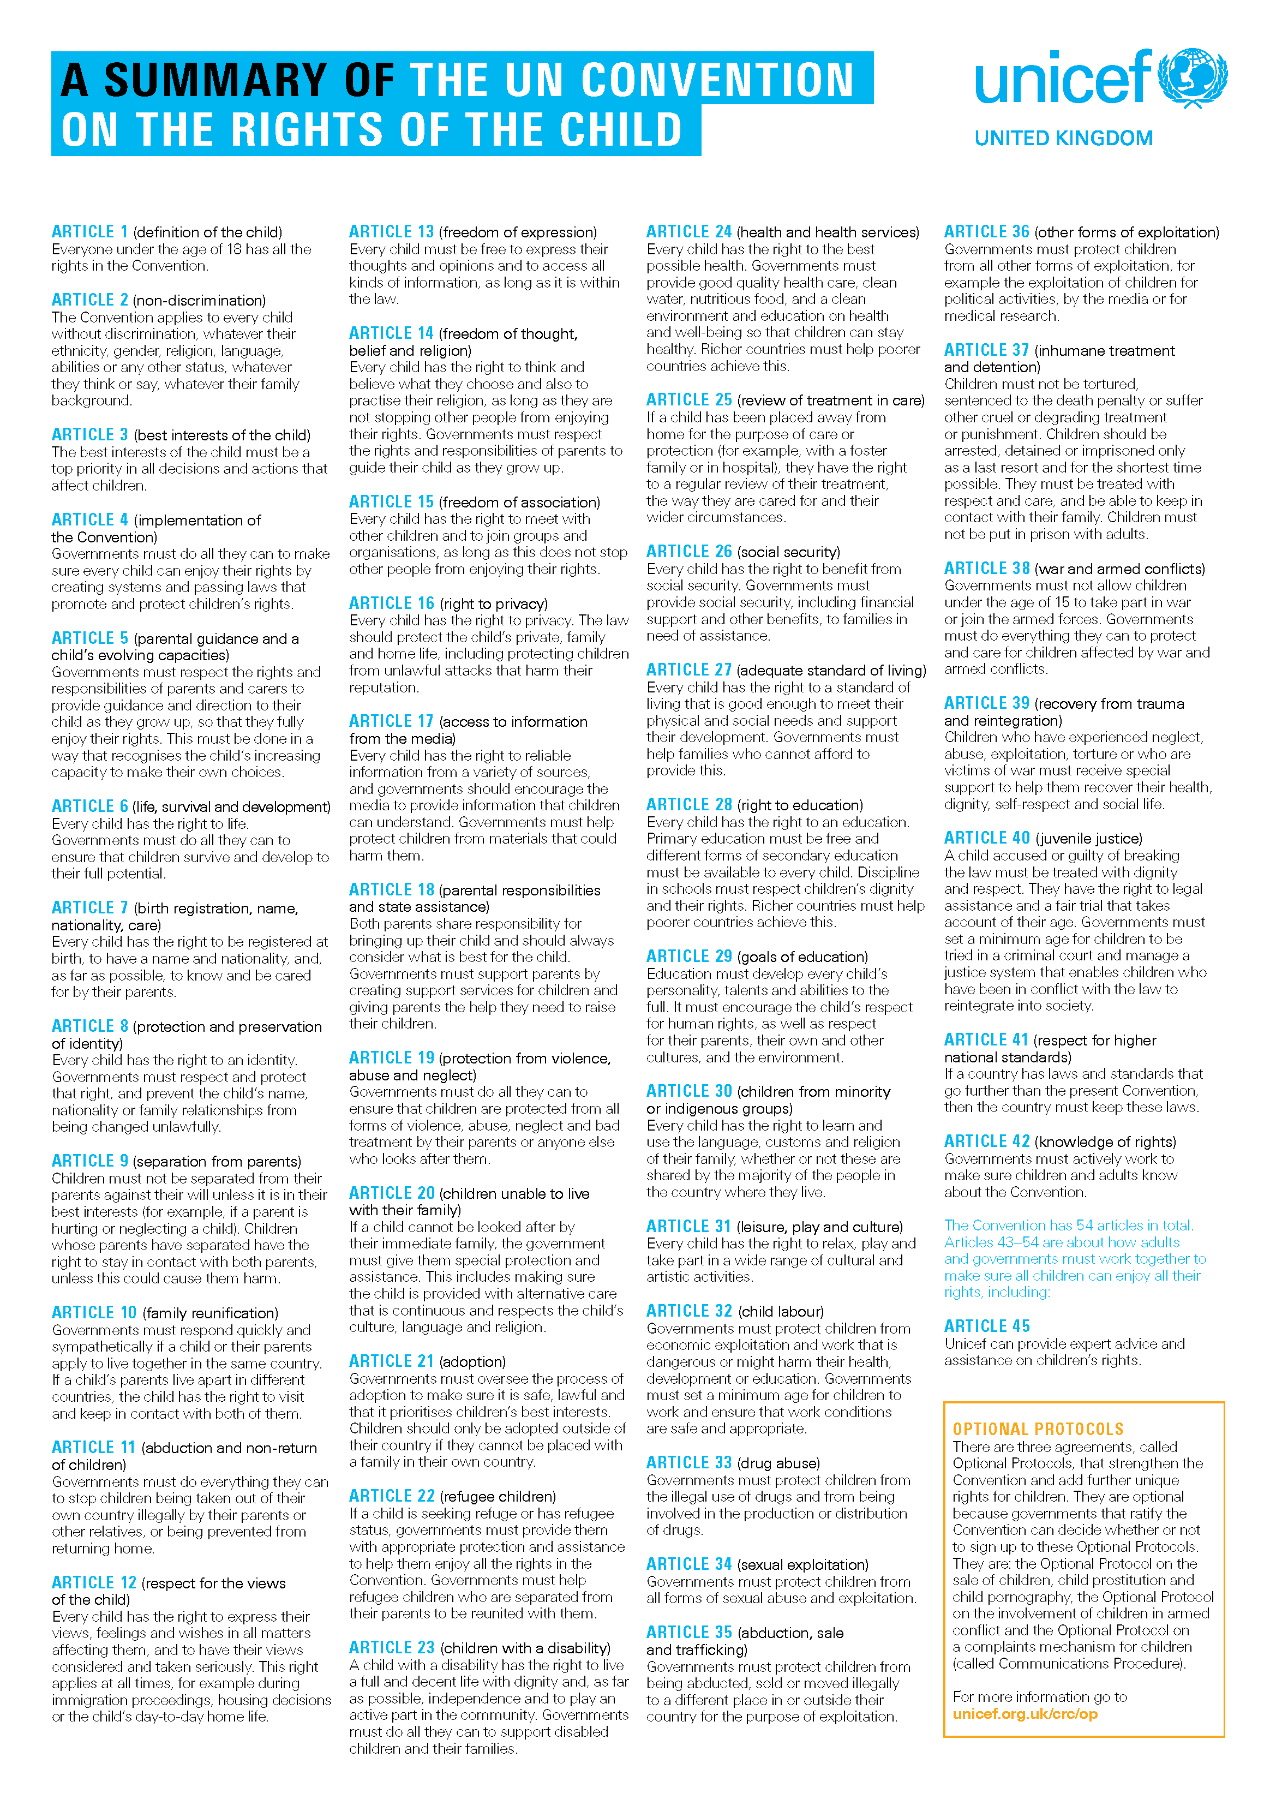

**Reference 5**

**European Charter for Persons with Autism**

People with autism should share the same rights and privileges enjoyed by all the European population where such are appropriate and in the best interests of the person with autism.

These rights should be enhanced, protected and enforced by appropriate legislation in each state.

The United Nations declaration on the Rights of Mentally Retarded Persons (1971) and the Rights of Handicapped Persons (1975) and other relevant declarations on human rights should be considered and in particular, for people with autism the following should be included:

1. The right of people with autism to live independent and full lives to the limit of their potential
2. The right of people with autism to an accessible, unbiased and accurate clinical diagnosis and assessment
3. The right of people with autism to accessible and appropriate education
4. The right of people with autism (and their representatives) to be involved in all decisions affecting their future; the wishes of the individual must be, as far as possible, ascertained and respected
5. The right of people with autism to accessible and suitable housing
6. The right of people with autism to the equipment, assistance and support services necessary to live a fully productive life with dignity and independence
7. The right of people with autism to an income or wage sufficient to provide adequate food, clothing, accommodation and the other necessities of life
8. The right of people with autism to participate, as far as possible, in the development and management of services provided for their wellbeing
9. The right of people with autism to appropriate counselling and care for their physical, mental and spiritual health; this includes the provision of appropriate treatment and medication administered in the best interest of the individual with all protective measures taken
10. The right of people with autism to meaningful employment and vocational training without discrimination or stereotype; training and employment should have regard to the ability and choice of the individual
11. The right of people with autism to accessible transport and freedom of movement
12. The right of people with autism to participate in and benefit from culture, entertainment, recreation and sport
13. The right of people with autism of equal access to and use of all facilities, services and activities in the community
14. The right of people with autism to sexual and other relationships, including marriage, without exploitation or coercion
15. The right of people with autism (and their representatives) to legal representation and assistance and to the full protection of all legal rights
16. The right of people with autism to freedom from fear or threat of unwarranted incarceration in psychiatric hospitals or any other restrictive institution
17. The right of people with autism to freedom from abusive physical treatment or neglect
18. The right of people with autism to freedom from pharmacological abuse or misuse
19. The right of access of people with autism (and their representatives) to all information contained in their personal, medical, psychological, psychiatric and educational records.

Presented at the 4th Autism-Europe Congress, Den Haag, 10 May 1992.

Adopted as a Written Declaration by the European Parliament on May 9th, 1996.

Autism-Europe, Avenue Van Becelaere 26B, bte 21, B - 1170 Bruxelles, Belgium

**Phone:** +32 2 675 75 05  
**Fax:** +32 2 675 72 70  
**E-mail:** [autisme.europe@arcadis.be](mailto:autisme.europe@arcadis.be)  
**Website:** [www.autismeurope.arc.be](http://www.autismeurope.arc.be/)

**Appendix 1**

**Female Genital Mutilation (FGM)**

**Mandatory Reporting Duty**

**FGM**

FGM comprises all procedures involving partial or total removal of the external female genitalia or other injury to the female genital organs. It is illegal in the UK and a form of child abuse with long-lasting harmful consequences.

**FGM mandatory reporting duty for teachers**

Section 5B of the Female Genital Mutilation Act 2003 (as inserted by section 74 of the Serious Crime Act 2015) places a statutory duty upon **teachers** along with regulated health and social care professionals in England and Wales, to report to the police where they discover (either through disclosure by the victim or visual evidence) that FGM appears to have been carried out on a girl under 18. Those failing to report such cases will face disciplinary sanctions. It will be rare for teachers to see visual evidence, and they should **not** be examining pupils or students, but the same definition of what is meant by “to discover that an act of FGM appears to have been carried out” is used for all professionals to whom this mandatory reporting duty applies. Information on when and how to make a report can be found at: Mandatory [reporting](https://www.gov.uk/government/publications/mandatory-reporting-of-female-genital-mutilation-procedural-information) of [female](https://www.gov.uk/government/publications/mandatory-reporting-of-female-genital-mutilation-procedural-information) genital mutilation procedural information[.](https://www.gov.uk/government/publications/mandatory-reporting-of-female-genital-mutilation-procedural-information)

Teachers **must** personally report to the police cases where they discover that an act of FGM appears to have been carried out.100 Unless the teacher has good reason not to, they should still consider and discuss any such case with the school’s or college’s designated safeguarding lead (or deputy) and involve children’s social care as appropriate. The duty does not apply in relation to at risk or suspected cases (i.e. where the teacher does not discover that an act of FGM appears to have been carried out, either through disclosure by the victim or visual evidence) or in cases where the woman is 18 or over. In these cases, teachers should follow local safeguarding procedures. The following is a useful summary of the FGM mandatory reporting duty: [FGM Fact Sheet.](https://www.gov.uk/government/uploads/system/uploads/attachment_data/file/496415/6_1639_HO_SP_FGM_mandatory_reporting_Fact_sheet_Web.pdf) (www.gov.uk)

**Appendix 2**

**Types of Abuse and Neglect**

All school and college staff should be aware that abuse, neglect and safeguarding issues are rarely standalone events that can be covered by one definition or label. In most cases, multiple issues will overlap with one another.

**Abuse:** a form of maltreatment of a child. Somebody may abuse or neglect a child by inflicting harm or by failing to act to prevent harm. Children may be abused in a family or in an institutional or community setting by those known to them or, more rarely, by others. Abuse can take place wholly online, or technology may be used to facilitate offline abuse. Children may be abused by an adult or adults or by another child or children.

**Physical abuse:** a form of abuse which may involve hitting, shaking, throwing, poisoning, burning or scalding, drowning, suffocating or otherwise causing physical harm to a child. Physical harm may also be caused when a parent or carer fabricates the symptoms of, or deliberately induces, illness in a child.

**Emotional abuse:** the persistent emotional maltreatment of a child such as to cause severe and adverse effects on the child’s emotional development. It may involve conveying to a child that they are worthless or unloved, inadequate, or valued only insofar as they meet the needs of another person. It may include not giving the child opportunities to express their views, deliberately silencing them or ‘making fun’ of what they say or how they communicate. It may feature age or developmentally inappropriate expectations being imposed on children. These may include interactions that are beyond a child’s developmental capability as well as overprotection and limitation of exploration and learning, or preventing the child from participating in normal social interaction. It may involve seeing or hearing the ill-treatment of another. It may involve serious bullying (including cyberbullying), causing children frequently to feel frightened or in danger, or the exploitation or corruption of children. Some level of emotional abuse is involved in all types of maltreatment of a child, although it may occur alone.

**Sexual abuse:** involves forcing or enticing a child or young person to take part in sexual activities, not necessarily involving a high level of violence, whether or not the child is aware of what is happening. The activities may involve physical contact, including assault by penetration (for example rape or oral sex) or non-penetrative acts such as masturbation, kissing, rubbing and touching outside of clothing. They may also include non-contact activities, such as involving children in looking at, or in the production of, sexual images, watching sexual activities, encouraging children to behave in sexually inappropriate ways, or grooming a child in preparation for abuse. Sexual abuse can take place online, and technology can be used to facilitate offline abuse. Sexual abuse is not solely perpetrated by adult males. Women can also commit acts of sexual abuse, as can other children. The sexual abuse of children by other children is a specific safeguarding issue in education (see Appendix 1).

**Neglect:** the persistent failure to meet a child’s basic physical and/or psychological needs, likely to result in the serious impairment of the child’s health or development. Neglect may occur during pregnancy, for example, as a result of maternal substance abuse. Once a child is born, neglect may involve a parent or carer failing to: provide adequate food, clothing and shelter (including exclusion from home or abandonment); protect a child from physical and emotional harm or danger; ensure adequate supervision (including the use of inadequate care-givers); or ensure access to appropriate medical care or treatment. It may also include neglect of, or unresponsiveness to, a child’s basic emotional needs.

**Specific safeguarding issues**

**All** staff should have an awareness of safeguarding issues that can put children at risk of harm. Behaviours linked to issues such as drug taking, alcohol abuse, deliberately missing education and sexting (also known as youth produced sexual imagery) put children in danger.

**All** staff should be aware that safeguarding issues can manifest themselves via peer on peer abuse. This is most likely to include, but may not be limited to:

* bullying (including cyberbullying);
* physical abuse such as hitting, kicking, shaking, biting, hair pulling, or otherwise causing physical harm;
* sexual violence and sexual harassment;
* sexting (also known as youth produced sexual imagery); and
* initiation/hazing type violence and rituals.

**All** staff should be clear as to the school’s or college’s policy and procedures with regards to peer on peer abuse.

Safeguarding incidents and/or behaviours can be associated with factors outside the school or college and/or can occur between children outside the school or college. All staff, but especially the designated safeguarding lead (and deputies) should be considering the context within which such incidents and/or behaviours occur. This is known as contextual safeguarding, which simply means assessments of children should consider whether wider environmental factors are present in a child’s life that are a threat to their safety and/or welfare. Children’s social care assessments should consider such factors so it is important that schools and colleges provide as much information as possible as part of the referral process. This will allow any assessment to consider all the available evidence and the full context of any abuse. Additional information regarding contextual safeguarding is available here: Contextual Safeguarding.

**Appendix 3**

**Wargrave House School & College**

**CAUSE FOR CONCERN**

|  |  |  |  |  |  |  |  |  |
| --- | --- | --- | --- | --- | --- | --- | --- | --- |
| **WHO IS YOUR CONCERN ABOUT?** | | | | | | | | |
| **Name** |  | | | | **Class** |  | **DoB** |  |
| **Status** please circle | **Day** | | **Tea Time** | | **STB** | | **Residential** | |
| **Who is reporting this concern?** | | | | | | | | |
| **Name** |  | | | | **Position** | |  | |
| **What are the circumstances of this concern?** | | | | | | | | |
| **Date** |  | **Time** | |  | **Environment** | |  | |
| **Persons present & position** | | | | | | | | |

|  |  |  |  |  |  |  |  |  |
| --- | --- | --- | --- | --- | --- | --- | --- | --- |
| **What is your concern?** | | | | | | | | |
| C:\Users\Sue Murphy\Desktop\332px-Outline-body.png | | | | | | | | |
| **Front** |  |  | | | | | | |
| **Back** |  |  | | | | | | |
| **What did you do?** | | | | | | | | |
| **Who** | | | **What** | | | | **When** | |
|  | | |  | | | |  | |
| **Report completed** | | | | | | | | |
| **Signed**  **(reporter)** | | |  | | | **Date** |  | |
| **Report received by?** | | | | | | | | |
| **Name** | | |  | **Signed** |  | **Time** | |  |
| **Date** | |  |

**Take this form to the (Operational) Deputy Designated Safeguarding Lead. In their absence the Deputy Designated Safeguarding Lead or Head of Education ( DSL)**

|  |  |  |  |  |  |
| --- | --- | --- | --- | --- | --- |
| **ACTION PLAN (to be completed by the Investigating Lead)** | | | | | |
| **Who** | **What** | | | **When** | **Complete** |
|  |  | | |  |  |
| **POST-INCIDENT SUMMARY** | | | | | |
| **Classification** | |  | | | |
| **Outcome** | | **Internal** | **External** | | |
|  |  | | |
| **DESIGNATED SAFEGUARDING LEAD** | | | | | |
| **Date received** | |  | | | |
| **Signed** | |  | | | |

**Appendix 4a**



1. In cases which also involve an allegation of abuse against a staff member, see Part four of this guidance.
2. Early help means providing support as soon as a problem emerges at any point in a child’s life. Where a child would benefit from co-ordinated early help, an early help inter-agency assessment should be arranged. Chapter one of Working together to safeguard children provides detailed guidance on the early help process.
3. Under the Children Act 1989, local authorities are required to provide services for children in need for the purposes of safeguarding and promoting their welfare. This can include s17 assessments of children in need and s47 assessments of children at risk of significant harm. Full details are in Chapter one of Working together to safeguard children
4. This could include applying for an Emergency Protection Order (EPO).

**Appendix 4b**

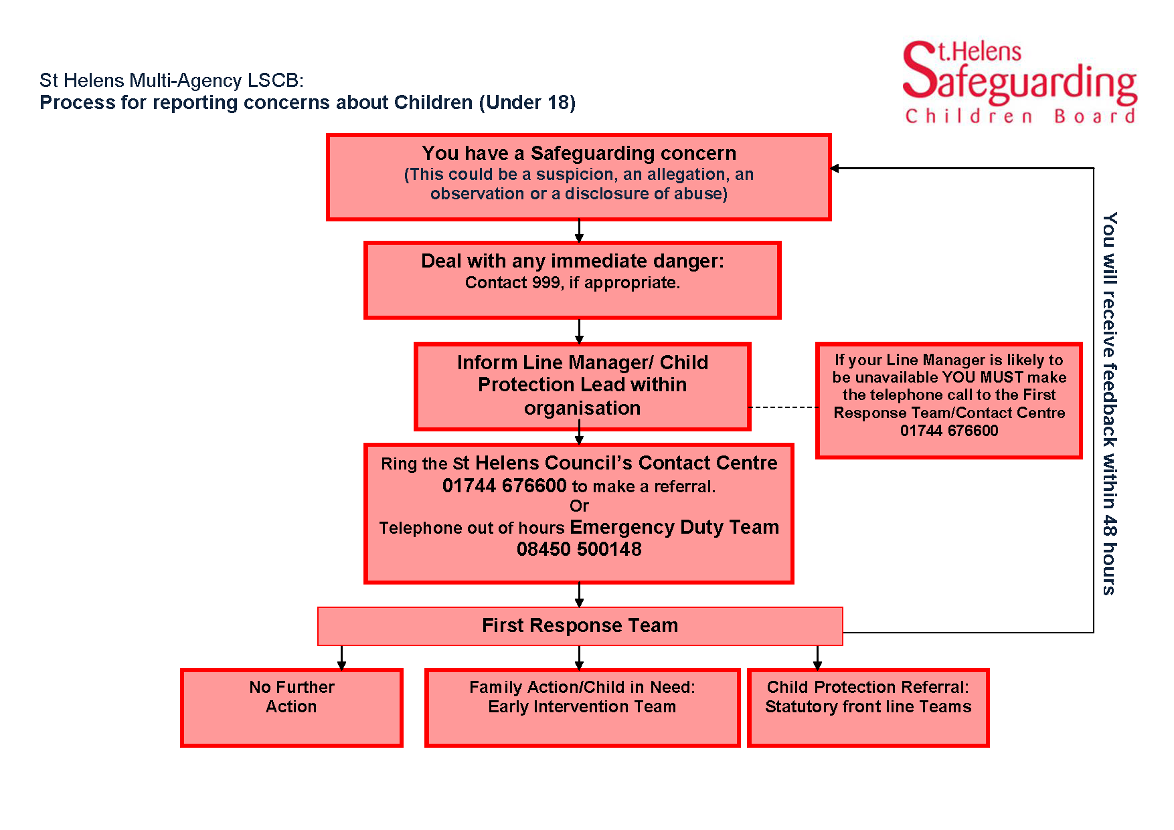

**Appendix 5**

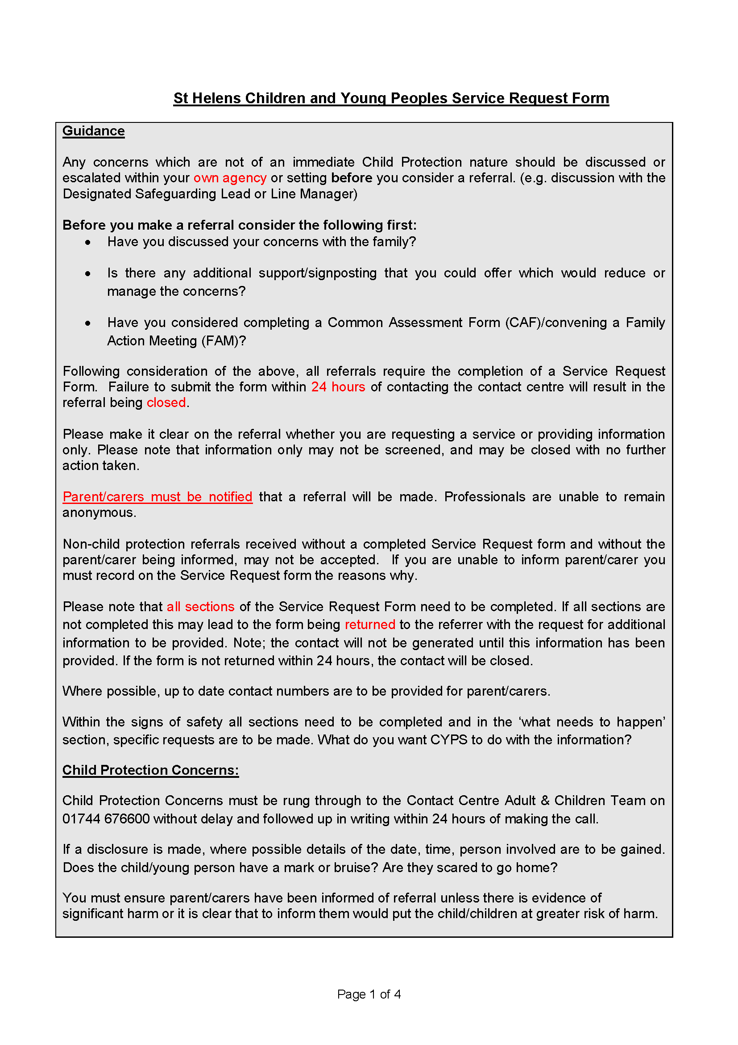

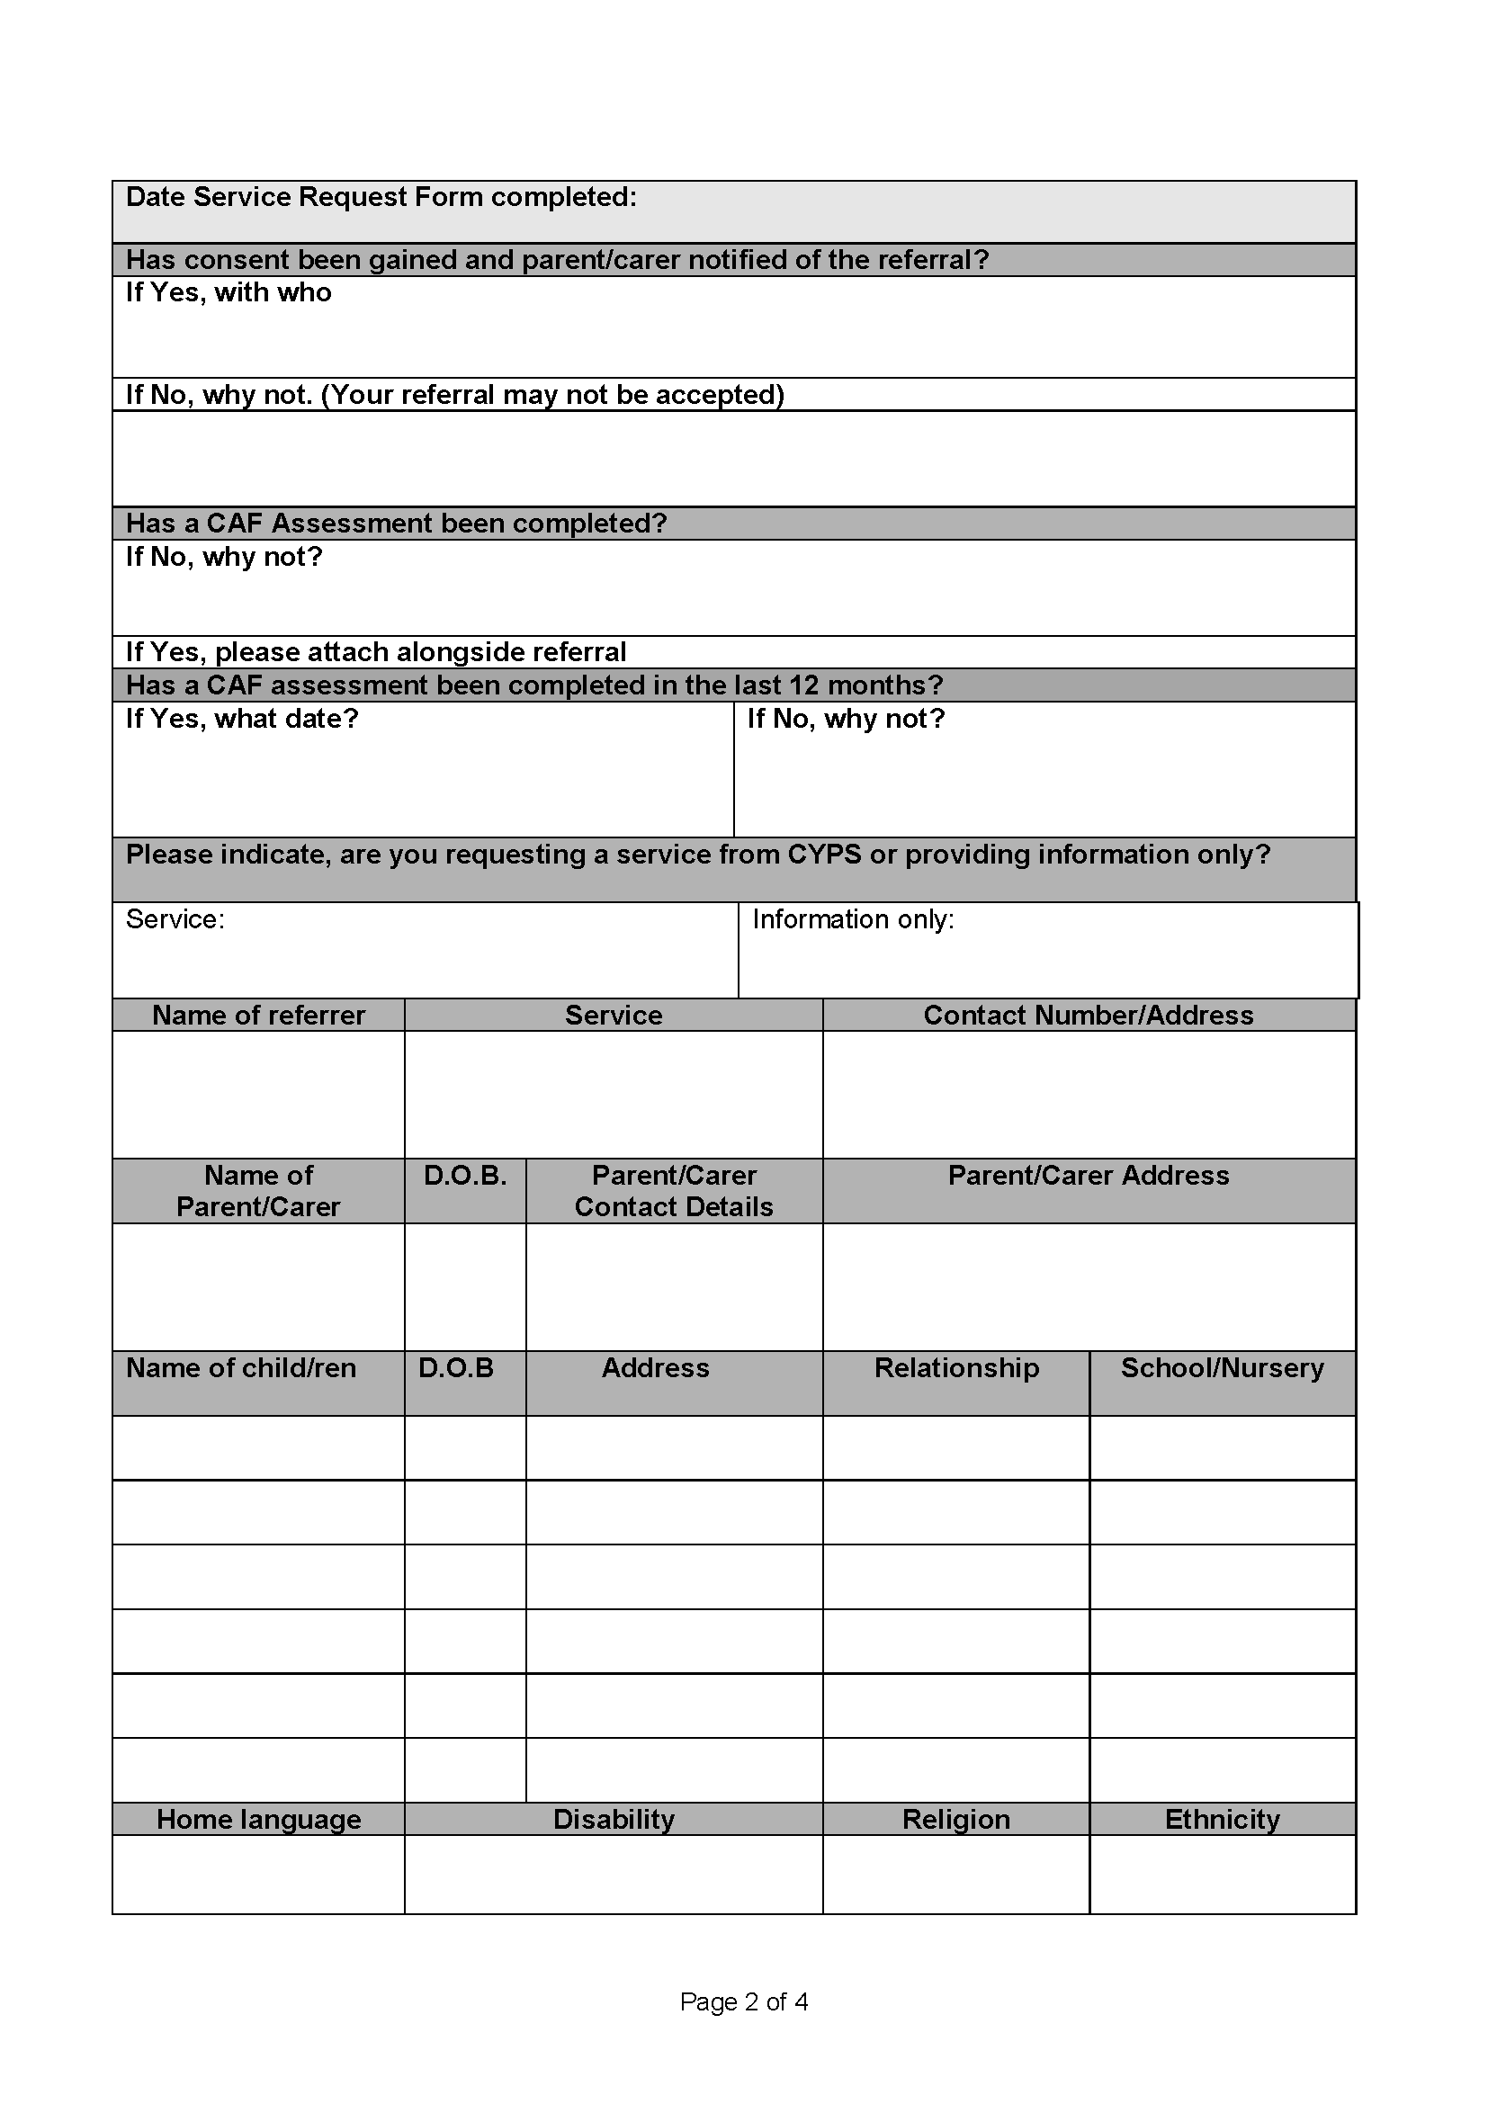

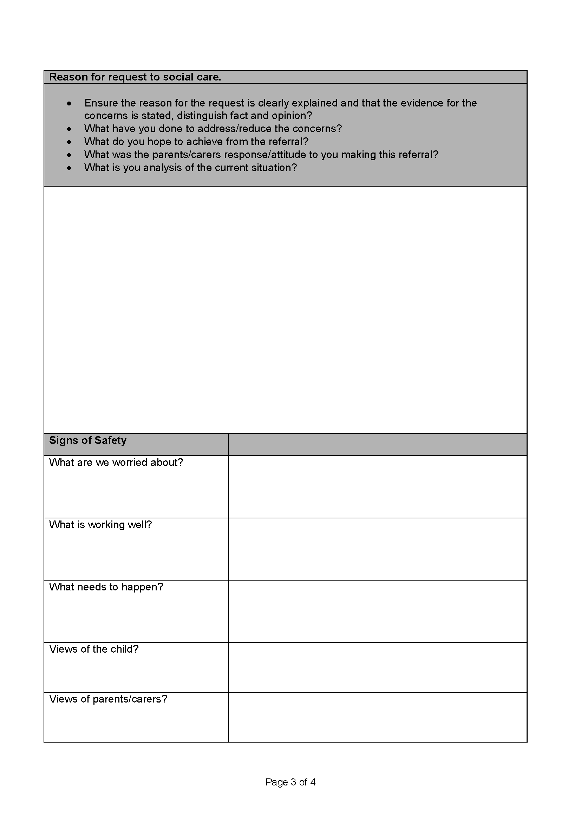

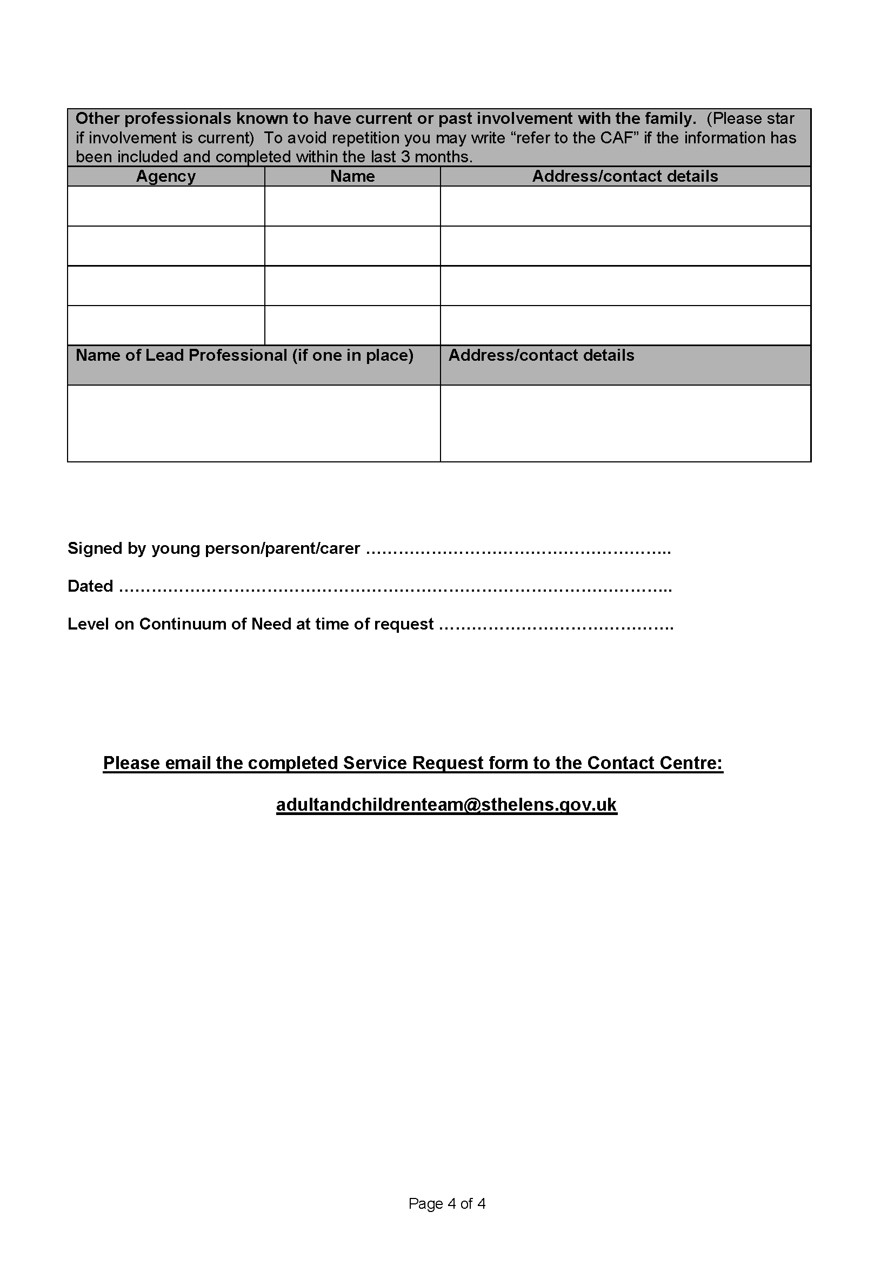

**Appendix 6**

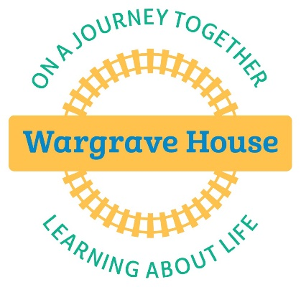

Wargrave House School & College

PRIVATE & CONFIDENTIAL

WELFARE LOG

|  |  |  |  |  |
| --- | --- | --- | --- | --- |
| Student: |  | | | |
| Book Number: |  | | | |
| CfC report initiating log: | Book |  | Page |  |
| Date Started: |  | | | |
| Date Finished: |  | | | |

WELFARE LOG

* This record has been initiated to track provision for an individual’s welfare and safety following a ‘Cause for Concern’ report.
* This record does not replace further cause for concern reports for additional issues or more serious concerns.
* Provide accurate, observed information. Do not make judgements, keep to the facts.
* Complete ALL columns (even if N/A).
* If you reference any other documents e.g. home/school book, copy the page and keep with this record.
* Pass this log to Stuart Jamieson (or other member of SLT in his absence) on a weekly basis (Friday afternoon/Monday morning).

If you are in any doubt, speak to the Designated/Deputy Safeguarding Lead immediately.

|  |  |  |  |
| --- | --- | --- | --- |
| Date | Concern/Observation | Action | Name |
|  |  |  |  |
|  |  |  |  |
|  |  |  |  |
|  |  |  |  |
|  |  |  |  |
|  |  |  |  |
|  |  |  |  |
|  |  |  |  |
|  |  |  |  |
|  |  |  |  |

**Appendix 7a**

**SAFEGUARDING FILE TRANSFER RECORD AND RECEIPT**

PART 1: To be completed by sending/transferring school or college

|  |  |
| --- | --- |
| NAME OF CHILD: | Former Student |
| DOB: |  |
| NAME OF SCHOOL SENDING CP FILE: | Wargrave House School & College |
| ADDRESS OF SENDING SCHOOL: | 449 Wargrave Road  Newton-le-Willows  Merseyside  WA12 8RS |
| METHOD OF DELIVERY: | BY HAND SECURE POST ELECTRONICALLY |
| DATE FILE SENT: |  |
| NAME OF DSL TRANSFERRING FILE: |  |
| NAME OF PERSON TRANFERRING TO: |  |
| SIGNATURE: |  |

PART 2: To be completed by receiving school or college

|  |  |
| --- | --- |
| NAME OF SCHOOL RECEIVING FILE: |  |
| ADDRESS: |  |
| DATE RECEIVED: |  |
| NAME OF PERSON RECEIVING FILE: |  |
| DATE CONFIRMATION OF RECEIPT SENT: |  |
| SIGNATURE: |  |

Receiving School: Please complete Part 2 and return this form to the Designated Safeguarding Lead listed in Part 1 above. You are advised to keep a copy for your own reference.

**Appendix 7b**

PRIVATE & CONFIDENTIAL

Headteacher

Designated Safeguarding Lead

Dear

Former Student dob: xxxx

As per the requirements of the Keeping Children Safe in Education guidance, please find enclosed the safeguarding records for the above named child who will be joining you in xxxx.

I would be grateful if you would complete the attached safeguarding file transfer record and return to me in the SAE provided.

If you have any queries regarding this, please do not hesitate to contact me at school.

Yours sincerely

Stuart Jamieson

Head of Education

Designated Safeguarding and Prevent Lead

[stuartjamieson@wargravehouse.com](mailto:genniehyde@wargravehouse.com)

Enc

**Appendix 8**

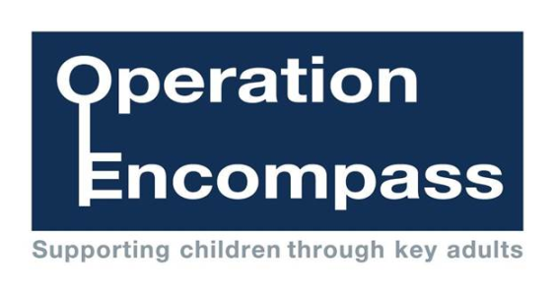

|  |  |  |  |
| --- | --- | --- | --- |
| **Police Ref No** |  | **Date** |  |
| **Childs name, age and DOB** |  | | |
| **Date and Time of incident**  **Address** |  | | |
| **Circumstances of incident** |  | | |
| **Additions school information including other operation encompass calls** |  | | |
| **Action taken and impact** |  | | |

**Appendix 9**

**Wargrave House**

**Record of Authorised Student Search**

|  |  |  |  |
| --- | --- | --- | --- |
| Details of Student Searched | | | |
| **Name:** |  | **Date of Birth:** |  |
| **Class:** |  | **Year Group:** |  |
| **Ethnicity:** |  | **Sex:** |  |

|  |  |  |  |
| --- | --- | --- | --- |
| **Grounds of Suspicion:** | | | |
| **Time:** |  | **Place:** |  |

|  |  |  |  |
| --- | --- | --- | --- |
| **Who carried out search (SMT only):** |  | **Consent given:** | **Please** |
| **Consent refused:** | **tick appropriate** |

|  |  |  |  |  |
| --- | --- | --- | --- | --- |
| **Who else was present during search** |  | | | |
| **What, if any, reasonable force was used, and if so why.** |  | | **Additional Record to be made in Record of Physical Intervention** | |
| **Describe how the search began and progressed** |  | | | |
| **What was the student’s response to being searched and how did staff managed that response (e.g. steps taken to calm the student)** |  | | | |
| **Outcomes** |  | | | |
| **Follow up actions** |  | | | |
| Signatures | | | | |
| **Student** |  | | | **Date:** |
| **Person who searched** |  | **Print Name** | | **Date:** |
| **Witness** |  | **Print Name** | | **Date:** |
| **Countersigned** |  | **Print Name** | | **Date:** |

**Appendix 10**

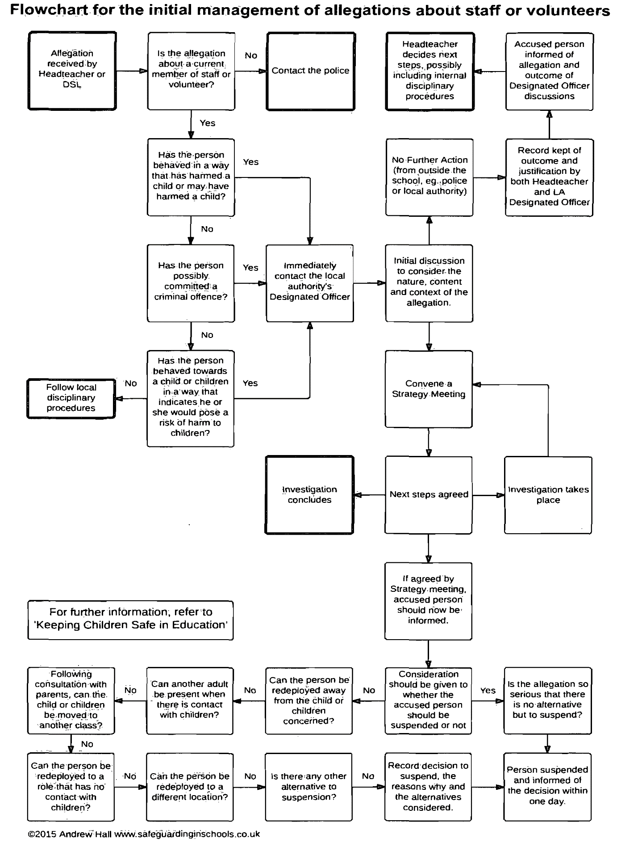

**Appendix 11**

**The seven golden rules to sharing information**

1. Remember that the General Data Protection Regulation (GDPR), Data Protection Ac t 2018 and human rights law are not barriers to justified information sharing, but provide a framework to ensure that personal information about living individuals is shared appropriately.
2. Be open and honest with the individual (and/or their family where appropriate) from the outset about why, what, how and with whom information will, or could be shared, and seek their agreement, unless itis unsafe or inappropriate to do so.
3. Seek advice from other practitioners, or your information governance lead, if you are in any doubt about sharing information concerned, without disclosing the identity of the individual where possible.
4. Where possible, share information with consent, and where possible, respect the wishes of those who do not consent to having their information shared. Under the GDPR and Data Protection Act 2018 you may share information without consent if, in your judgement, there is a lawful basis to do so, such as where safety may be at risk. You will need to base your judgement on the facts of the case. When you are sharing or requesting personal information from someone, be clear of the basis upon which you are doing so. Where you do not have consent, be mindful that an individual might not expect information to be shared.
5. Consider safety and well-being: base your information sharing decisions on considerations of the safety and well-being of the individual and others who may be affected by their actions.
6. Necessary, proportionate, relevant, adequate, accurate, timely and secure: ensure that the information you share is necessary for the purpose for which you are sharing it, is shared only with those individuals who need to have it, is accurate and up-to-date, is shared in a timely fashion, and is shared securely (see principles).
7. Keep a record of your decision and the reasons for it – whether it is to share information or not. If you decide to share, then record what you have shared, with whom and for what purpose.

**Appendix 12**

**Keeping children safe in education**

**Statutory guidance for schools and colleges**

**Part one: Information for all school and college staff**

**September 2019**

**Contents**

**Summary 3**

**Part one: Safeguarding information for all staff 4**

**What school and college staff should know and do 4**

**The role of school and college staff 4**

**What school and college staff need to know 5**

**What school and college staff should look out for 6**

**Abuse and neglect 7**

**Safeguarding issues 8**

**Peer on peer abuse 8**

**Serious violence 9**

**Female Genital Mutilation 9**

**Contextual safeguarding 10**

**Additional information and support 10**

**What school and college staff should do if they have concerns about a child 10**

**Early help 11**

**Statutory assessments 12**

**What will the local authority do? 12**

**Record keeping 13**

**Why is all of this important? 13**

**What school and college staff should do if they have concerns about another staff member who may pose a risk of harm to children 14**

**What school or college staff should do if they have concerns about safeguarding practices within the school or college 14**

**Annex A - Further information about specific forms of abuse and safeguarding issues 16**

**Hyperlinks to other relevant guidance 28**

**Summary**

**Keeping Children Safe in Education is statutory guidance that schools and colleges in England must have regard to when carrying out their duties to safeguard and promote the welfare of children.**

**• Governing bodies of maintained schools (including maintained nursery schools) and colleges;**

**• Proprietors of independent schools (including academies, free schools and alternative provision academies) and non-maintained special schools. In the case of academies, free schools and alternative provision academies, the proprietor will be the academy trust; and**

**• Management committees of pupil referral units (PRUs)**

**are asked to ensure that all staff in their school or college read at least Part one of the guidance.**

**For ease of reference Part one is set out here as a standalone document.**

**Part one: Safeguarding information for all staff**

**What school and college staff should know and do**

**A child centred and coordinated approach to safeguarding**

**1. Schools and colleges and their staff are an important part of the wider safeguarding system for children. This system is described in statutory guidance Working Together to Safeguard Children**

**2. Safeguarding and promoting the welfare of children is everyone’s responsibility. Everyone who comes into contact with children and their families has a role to play. In order to fulfil this responsibility effectively, all practitioners should make sure their approach is child-centred. This means that they should consider, at all times, what is in the best interests of the child.**

**3. No single practitioner can have a full picture of a child’s needs and circumstances. If children and families are to receive the right help at the right time, everyone who comes into contact with them has a role to play in identifying concerns, sharing information and taking prompt action.**

**4. Safeguarding and promoting the welfare of children is defined for the purposes of this guidance as:**

**• protecting children from maltreatment;**

**• preventing impairment of children’s health or development;**

**• ensuring that children grow up in circumstances consistent with the provision of safe and effective care; and**

**• taking action to enable all children to have the best outcomes.**

**5. Children includes everyone under the age of 18.**

**The role of school and college staff**

**6. School and college staff are particularly important as they are in a position to identify concerns early, provide help for children, and prevent concerns from escalating.**

**7. All staff have a responsibility to provide a safe environment in which children can learn.**

**8. All staff should be prepared to identify children who may benefit from early help.1 Early help means providing support as soon as a problem emerges at any point in a child’s life, from the foundation years through to the teenage years.**

**9. Any staff member who has a concern about a child’s welfare should follow the referral processes set out in paragraphs 36-47. Staff should expect to support social workers and other agencies following any referral.**

**10. Every school and college should have a designated safeguarding lead who will provide support to staff to carry out their safeguarding duties and who will liaise closely with other services such as children’s social care.**

**11. The designated safeguarding lead (and any deputies) are most likely to have a complete safeguarding picture and be the most appropriate person to advise on the response to safeguarding concerns.**

**12. The Teachers’ Standards 2012 state that teachers (which includes headteachers) should safeguard children’s wellbeing and maintain public trust in the teaching profession as part of their professional duties.2**

**What school and college staff need to know**

**13. All staff should be aware of systems within their school or college which support safeguarding and these should be explained to them as part of staff induction. This should include:**

**• the child protection policy;**

**• the behaviour policy;3**

**• the staff behaviour policy (sometimes called a code of conduct);**

**• the role of the designated safeguarding lead (including the identity of the designated safeguarding lead and any deputies).**

**Copies of policies and a copy of Part one of this document should be provided to staff at induction.**

**1 Detailed information on early help can be found in Chapter 1 of Working Together to Safeguard Children.**

**2 The Teachers' Standards apply to: trainees working towards QTS; all teachers completing their statutory induction period (newly qualified teachers [NQTs]); and teachers in maintained schools, including maintained special schools, who are subject to the Education (School Teachers’ Appraisal) (England) Regulations 2012.**

**3 All schools are required to have a behaviour policy (read Behaviour and school discipline in schools). If a college chooses to have a behaviour policy it should be provided to staff as described above.**

**14. All staff should receive appropriate safeguarding and child protection training which is regularly updated. In addition, all staff should receive safeguarding and child protection updates (for example, via email, e-bulletins and staff meetings), as required, and at least annually, to provide them with relevant skills and knowledge to safeguard children effectively.**

**15. All staff should be aware of their local early help4 process and understand their role in it.**

**16. All staff should be aware of the process for making referrals to children’s social care and for statutory assessments under the Children Act 1989, especially section 17 (children in need) and section 47 (a child suffering, or likely to suffer, significant harm) that may follow a referral, along with the role they might be expected to play in such assessments.5**

**17. All staff should know what to do if a child tells them he/she is being abused or neglected. Staff should know how to manage the requirement to maintain an appropriate level of confidentiality. This means only involving those who need to be involved, such as the designated safeguarding lead (or a deputy) and children’s social care. Staff should never promise a child that they will not tell anyone about a report of abuse, as this may ultimately not be in the best interests of the child.**

**What school and college staff should look out for**

**Early Help**

**18. Any child may benefit from early help, but all school and college staff should be particularly alert to the potential need for early help for a child who:**

**• is disabled and has specific additional needs;**

**• has special educational needs (whether or not they have a statutory Education, Health and Care Plan);**

**• is a young carer;**

**• is showing signs of being drawn in to anti-social or criminal behaviour, including gang involvement and association with organised crime groups;**

**• is frequently missing/goes missing from care or from home;**

**• is at risk of modern slavery, trafficking or exploitation;**

**4 Detailed information on early help can be found in Chapter 1 of Working Together to Safeguard Children. 5 More information on statutory assessments is included at paragraph 42. Detailed information on statutory assessments can be found in Chapter 1 of Working Together to Safeguard Children.**

**• is at risk of being radicalised or exploited;**

**• is in a family circumstance presenting challenges for the child, such as drug and alcohol misuse, adult mental health issues and domestic abuse;**

**• is misusing drugs or alcohol themselves;**

**• has returned home to their family from care; and**

**• is a privately fostered child.**

**Abuse and neglect**

**19. Knowing what to look for is vital to the early identification of abuse and neglect. All staff should be aware of indicators of abuse and neglect so that they are able to identify cases of children who may be in need of help or protection. If staff are unsure, they should always speak to the designated safeguarding lead (or deputy).**

**20. All school and college staff should be aware that abuse, neglect and safeguarding issues are rarely standalone events that can be covered by one definition or label. In most cases, multiple issues will overlap with one another.**

**Indicators of abuse and neglect**

**21. Abuse: a form of maltreatment of a child. Somebody may abuse or neglect a child by inflicting harm or by failing to act to prevent harm. Children may be abused in a family or in an institutional or community setting by those known to them or, more rarely, by others. Abuse can take place wholly online, or technology may be used to facilitate offline abuse. Children may be abused by an adult or adults or by another child or children.**

**22. Physical abuse: a form of abuse which may involve hitting, shaking, throwing, poisoning, burning or scalding, drowning, suffocating or otherwise causing physical harm to a child. Physical harm may also be caused when a parent or carer fabricates the symptoms of, or deliberately induces, illness in a child.**

**23. Emotional abuse: the persistent emotional maltreatment of a child such as to cause severe and adverse effects on the child’s emotional development. It may involve conveying to a child that they are worthless or unloved, inadequate, or valued only insofar as they meet the needs of another person. It may include not giving the child opportunities to express their views, deliberately silencing them or ‘making fun’ of what they say or how they communicate. It may feature age or developmentally inappropriate expectations being imposed on children. These may include interactions that are beyond a child’s developmental capability as well as overprotection and limitation of exploration and learning, or preventing the child from participating in normal social interaction. It may involve seeing or hearing the ill-treatment of another. It may involve serious bullying (including cyberbullying), causing children frequently to feel frightened or in danger, or**

**the exploitation or corruption of children. Some level of emotional abuse is involved in all types of maltreatment of a child, although it may occur alone.**

**24. Sexual abuse: involves forcing or enticing a child or young person to take part in sexual activities, not necessarily involving a high level of violence, whether or not the child is aware of what is happening. The activities may involve physical contact, including assault by penetration (for example rape or oral sex) or non-penetrative acts such as masturbation, kissing, rubbing and touching outside of clothing. They may also include non-contact activities, such as involving children in looking at, or in the production of, sexual images, watching sexual activities, encouraging children to behave in sexually inappropriate ways, or grooming a child in preparation for abuse. Sexual abuse can take place online, and technology can be used to facilitate offline abuse. Sexual abuse is not solely perpetrated by adult males. Women can also commit acts of sexual abuse, as can other children. The sexual abuse of children by other children is a specific safeguarding issue in education (see paragraph 27).**

**25. Neglect: the persistent failure to meet a child’s basic physical and/or psychological needs, likely to result in the serious impairment of the child’s health or development. Neglect may occur during pregnancy, for example, as a result of maternal substance abuse. Once a child is born, neglect may involve a parent or carer failing to: provide adequate food, clothing and shelter (including exclusion from home or abandonment); protect a child from physical and emotional harm or danger; ensure adequate supervision (including the use of inadequate care-givers); or ensure access to appropriate medical care or treatment. It may also include neglect of, or unresponsiveness to, a child’s basic emotional needs.**

**Safeguarding issues**

**26. All staff should have an awareness of safeguarding issues that can put children at risk of harm. Behaviours linked to issues such as drug taking, alcohol abuse, deliberately missing education and sexting (also known as youth produced sexual imagery) put children in danger.**

**Peer on peer abuse**

**27. All staff should be aware that children can abuse other children (often referred to as peer on peer abuse). This is most likely to include, but may not be limited to:**

**• bullying (including cyberbullying);**

**• physical abuse such as hitting, kicking, shaking, biting, hair pulling, or otherwise causing physical harm;**

**• sexual violence,6 such as rape, assault by penetration and sexual assault;**

**• sexual harassment,7 such as sexual comments, remarks, jokes and online sexual harassment, which may be standalone or part of a broader pattern of abuse;**

**• upskirting,8 which typically involves taking a picture under a person’s clothing without them knowing, with the intention of viewing their genitals or buttocks to obtain sexual gratification, or cause the victim humiliation, distress or alarm;**

**• sexting (also known as youth produced sexual imagery); and**

**• initiation/hazing type violence and rituals.**

**28. All staff should be clear as to the school’s or college’s policy and procedures with regards to peer on peer abuse.**

**Serious violence**

**29. All staff should be aware of indicators, which may signal that children are at risk from, or are involved with serious violent crime. These may include increased absence from school, a change in friendship or relationships with older individuals or groups, a significant decline in performance, signs of self-harm or a significant change in wellbeing, or signs of assault or unexplained injuries. Unexplained gifts or new possessions could also indicate that children have been approached by, or are involved with, individuals associated with criminal networks or gangs.**

**All staff should be aware of the associated risks and understand the measures in place to manage these. Advice for schools and colleges is provided in the Home Office’s Preventing youth violence and gang involvement and its Criminal exploitation of children and vulnerable adults: county lines guidance.9**

**Female Genital Mutilation**

**30. Whilst all staff should speak to the designated safeguarding lead (or deputy) with regard to any concerns about female genital mutilation (FGM), there is a specific legal duty on teachers.10 If a teacher, in the course of their work in the profession, discovers that an act of FGM appears to have been carried out on a girl under the age of 18, the teacher must report this to the police. See Annex A for further details.**

**6 For further information about sexual violence see Annex A.**

**7 For further information about sexual harassment see Annex A.**

**8 For further information about ‘upskirting’ see Annex A.**

**9 For further information about violent crime see Annex A.**

**10 Under Section 5B(11) (a) of the Female Genital Mutilation Act 2003, “teacher” means, in relation to England, a person within section 141A(1) of the Education Act 2002 (persons employed or engaged to carry out teaching work at schools and other institutions in England).**

**Contextual safeguarding**

**31. Safeguarding incidents and/or behaviours can be associated with factors outside the school or college and/or can occur between children outside the school or college. All staff, but especially the designated safeguarding lead (and deputies) should be considering the context within which such incidents and/or behaviours occur. This is known as contextual safeguarding, which simply means assessments of children should consider whether wider environmental factors are present in a child’s life that are a threat to their safety and/or welfare. Children’s social care assessments should consider such factors so it is important that schools and colleges provide as much information as possible as part of the referral process. This will allow any assessment to consider all the available evidence and the full context of any abuse. Additional information regarding contextual safeguarding is available here: Contextual Safeguarding.**

**Additional information and support**

**32. Departmental advice What to Do if You Are Worried a Child is Being Abused - Advice for Practitioners provides more information on understanding and identifying abuse and neglect. Examples of potential indicators of abuse and neglect are highlighted throughout the advice and will be particularly helpful for school and college staff. The NSPCC website also provides useful additional information on abuse and neglect and what to look out for.**

**33. Annex A contains important additional information about specific forms of abuse and safeguarding issues. School and college leaders and those staff who work directly with children should read the annex.**

**What school and college staff should do if they have concerns about a child**

**34. Staff working with children are advised to maintain an attitude of ‘it could happen here’ where safeguarding is concerned. When concerned about the welfare of a child, staff should always act in the best interests of the child.**

**35. If staff have any concerns about a child’s welfare, they should act on them immediately. See page 15 for a flow chart setting out the process for staff when they have concerns about a child.**

**36. If staff have a concern, they should follow their own organisation’s child protection policy and speak to the designated safeguarding lead (or deputy).**

**37. Options will then include:**

**• managing any support for the child internally via the school’s or college’s own pastoral support processes;**

**• an early help assessment;11 or**

**• a referral for statutory services,12 for example as the child might be in need, is in need or suffering or likely to suffer harm.**

**38. The designated safeguarding lead or a deputy should always be available to discuss safeguarding concerns. If in exceptional circumstances, the designated safeguarding lead (or deputy) is not available, this should not delay appropriate action being taken. Staff should consider speaking to a member of the senior leadership team and/or take advice from local children’s social care. In these circumstances, any action taken should be shared with the designated safeguarding lead (or deputy) as soon as is practically possible.**

**39. Staff should not assume a colleague or another professional will take action and share information that might be critical in keeping children safe. They should be mindful that early information sharing is vital for effective identification, assessment and allocation of appropriate service provision. Information Sharing: Advice for Practitioners Providing Safeguarding Services to Children, Young People, Parents and Carers supports staff who have to make decisions about sharing information. This advice includes the seven golden rules for sharing information and considerations with regard to the Data Protection Act 2018 and General Data Protection Regulation (GDPR). If in any doubt about sharing information, staff should speak to the designated safeguarding lead or a deputy. Fears about sharing information must not be allowed to stand in the way of the need to promote the welfare, and protect the safety, of children.**

**Early help**

**40. If early help is appropriate, the designated safeguarding lead (or deputy) will generally lead on liaising with other agencies and setting up an inter-agency assessment as appropriate. Staff may be required to support other agencies and professionals in an early help assessment, in some cases acting as the lead practitioner. Any such cases should be kept under constant review and consideration given to a referral to children’s**

**11 Further information on early help assessments, provision of early help services and accessing services is in Chapter 1 of Working Together to Safeguard Children.**

**12 Chapter 1 of Working Together to Safeguard Children sets out that the safeguarding partners should publish a threshold document that should include the criteria, including the level of need, for when a case should be referred to local authority children’s social care for assessment and for statutory services under section 17 and 47.**

**Local authorities, with their partners, should develop and publish local protocols for assessment. A local protocol should set out clear arrangements for how cases will be managed once a child is referred into local authority children’s social care.**

**social care for assessment for statutory services, if the child’s situation does not appear to be improving or is getting worse.**

**Statutory assessments**

**41. Where a child is suffering, or is likely to suffer from harm, it is important that a referral to children’s social care (and if appropriate the police) is made immediately. Referrals should follow the local referral process.**

**Children in need**

**A child in need is defined under the Children Act 1989 as a child who is unlikely to achieve or maintain a reasonable level of health or development, or whose health and development is likely to be significantly or further impaired, without the provision of services; or a child who is disabled. Local authorities are required to provide services for children in need for the purposes of safeguarding and promoting their welfare. Children in need may be assessed under section 17 of the Children Act 1989.**

**Children suffering or likely to suffer significant harm**

**Local authorities, with the help of other organisations as appropriate, have a duty to make enquiries under section 47 of the Children Act 1989 if they have reasonable cause to suspect that a child is suffering, or is likely to suffer, significant harm. Such enquiries enable them to decide whether they should take any action to safeguard and promote the child’s welfare and must be initiated where there are concerns about maltreatment, including all forms of abuse and neglect, female genital mutilation or other so-called honour based violence, and extra-familial threats like radicalisation and sexual exploitation.**

**42. The online tool Report Child Abuse to Your Local Council directs to the relevant local children’s social care contact number.**

**What will the local authority do?**

**43. Within one working day of a referral being made, a local authority social worker should acknowledge receipt to the referrer and make a decision about the next steps and the type of response that is required. This will include determining whether:**

**• the child requires immediate protection and urgent action is required;**

**• the child is in need, and should be assessed under section 17 of the Children Act 1989;**

**• there is reasonable cause to suspect the child is suffering or likely to suffer**

**significant harm, and whether enquiries must be made and the child assessed under section 47 of the Children Act 1989;**

**• any services are required by the child and family and what type of services**

**• further specialist assessments are required to help the local authority to decide what further action to take;**

**• to see the child as soon as possible if the decision is taken that the referral requires further assessment.**

**44. The referrer should follow up if this information is not forthcoming.**

**45. If social workers decide to carry out a statutory assessment, staff should do everything they can to support that assessment (supported by the designated safeguarding lead (or deputy) as required).**

**46. If, after a referral, the child’s situation does not appear to be improving, the referrer should consider following local escalation procedures to ensure their concerns have been addressed and, most importantly, that the child’s situation improves.**

**Record keeping**

**47. All concerns, discussions and decisions made, and the reasons for those decisions, should be recorded in writing. If in doubt about recording requirements, staff should discuss with the designated safeguarding lead (or deputy).**

**Why is all of this important?**

**48. It is important for children to receive the right help at the right time to address risks and prevent issues escalating. Research and serious case reviews have repeatedly shown the dangers of failing to take effective action.13 Examples of poor practice include:**

**• failing to act on and refer the early signs of abuse and neglect;**

**• poor record keeping;**

**• failing to listen to the views of the child;**

**• failing to re-assess concerns when situations do not improve;**

**• not sharing information;**

**• sharing information too slowly; and**

**13 An analysis of serious case reviews can be found at Serious case reviews, 2011 to 2014.**

**• a lack of challenge to those who appear not to be taking action.**

**What school and college staff should do if they have concerns about another staff member who may pose a risk of harm to children**

**49. If staff have safeguarding concerns, or an allegation is made about another member of staff (including volunteers) posing a risk of harm to children, then:**

**• this should be referred to the headteacher or principal;**

**• where there are concerns/allegations about the headteacher or principal, this should be referred to the chair of governors, chair of the management committee or proprietor of an independent school; and**

**• in the event of concerns/allegations about the headteacher, where the headteacher is also the sole proprietor of an independent school, allegations should be reported directly to the designated officer(s) at the local authority. (Further details can be found in Part four of this guidance).**

**What school or college staff should do if they have concerns about safeguarding practices within the school or college**

**50. All staff and volunteers should feel able to raise concerns about poor or unsafe practice and potential failures in the school’s or college’s safeguarding regime and know that such concerns will be taken seriously by the senior leadership team.**

**51. Appropriate whistleblowing procedures, should be put in place for such concerns to be raised with the school’s or college’s senior leadership team.**

**52. Where a staff member feels unable to raise an issue with their employer, or feels that their genuine concerns are not being addressed, other whistleblowing channels may be open to them:**

**• General guidance on whistleblowing can be found via: Advice on Whistleblowing.**

**• The NSPCC’s what you can do to report abuse dedicated helpline is available as an alternative route for staff who do not feel able to raise concerns regarding child protection failures internally or have concerns about the way a concern is being handled by their school or college. Staff can call 0800 028 0285 – line is available from 8:00 AM to 8:00 PM, Monday to Friday and email: help@nspcc.org.uk.14**

**14 Alternatively, staff can write to: National Society for the Prevention of Cruelty to Children (NSPCC), Weston House, 42 Curtain, Road, London EC2A 3NH.**

**Annex A - Further information about specific forms of abuse and safeguarding issues**

**Annex A contains important additional information about specific forms of abuse and safeguarding issues. School and college leaders and those staff who work directly with children should read this annex.**

**As per Part one of this guidance, if staff have any concerns about a child’s welfare, they should act on them immediately. They should follow their own organisation’s child protection policy and speak to the designated safeguarding lead (or deputy).**

**Where a child is suffering, or is likely to suffer from harm, it is important that a referral to children’s social care (and if appropriate the police) is made immediately.**

**Annex A Index**

**Children and the court system 17**

**Children missing from education 17**

**Children with family members in prison 17**

**Child sexual exploitation 17**

**Child criminal exploitation: county lines 19**

**Domestic abuse 19**

**Homelessness 20**

**So-called ‘honour-based’ violence (including Female Genital Mutilation and Forced Marriage) 21**

**FGM 21**

**FGM mandatory reporting duty for teachers 21**

**Forced marriage 22**

**Preventing radicalisation 23**

**Peer on peer abuse 24**

**Sexual violence and sexual harassment between children in schools and colleges 25**

**What is Sexual violence and sexual harassment? 25**

**Upskirting 27**

**Children and the court system**

**Children are sometimes required to give evidence in criminal courts, either for crimes committed against them or for crimes they have witnessed. There are two age appropriate guides to support children 5-11-year olds and 12-17 year olds.**

**The guides explain each step of the process and support and special measures that are available. There are diagrams illustrating the courtroom structure and the use of video links is explained.**

**Making child arrangements via the family courts following separation can be stressful and entrench conflict in families. This can be stressful for children. The Ministry of Justice has launched an online child arrangements information tool with clear and concise information on the dispute resolution service. This may be useful for some parents and carers.**

**Children missing from education**

**All staff should be aware that children going missing, particularly repeatedly, can act as a vital warning sign of a range of safeguarding possibilities. This may include abuse and neglect, which may include sexual abuse or exploitation and child criminal exploitation. It may indicate mental health problems, risk of substance abuse, risk of travelling to conflict zones, risk of female genital mutilation or risk of forced marriage. Early intervention is necessary to identify the existence of any underlying safeguarding risk and to help prevent the risks of a child going missing in future. Staff should be aware of their school’s or college’s unauthorised absence and children missing from education procedures.**

**Children with family members in prison**

**Approximately 200,000 children in England and Wales have a parent sent to prison each year. These children are at risk of poor outcomes including poverty, stigma, isolation and poor mental health. NICCO provides information designed to support professionals working with offenders and their children, to help mitigate negative consequences for those children.**

**Child sexual exploitation**

**Child sexual exploitation is a form of child sexual abuse. It occurs where an individual or group takes advantage of an imbalance of power to coerce, manipulate or deceive a child or young person under the age of 18 into sexual activity (a) in exchange for something the victim needs or wants, and/or (b) for the financial advantage or increased status of the perpetrator or facilitator. The victim may have been sexually exploited even if the**

**sexual activity appears consensual. Child sexual exploitation does not always involve physical contact: it can also occur through the use of technology. Like all forms of child sex abuse, child sexual exploitation:**

**• can affect any child or young person (male or female) under the age of 18 years, including 16 and 17 year olds who can legally consent to have sex;**

**• can still be abuse even if the sexual activity appears consensual;**

**• can include both contact (penetrative and non-penetrative acts) and non-contact sexual activity;**

**• can take place in person or via technology, or a combination of both;**

**• can involve force and/or enticement-based methods of compliance and may, or may not, be accompanied by violence or threats of violence;**

**• may occur without the child or young person’s immediate knowledge (e.g. through others copying videos or images they have created and posted on social media);**

**• can be perpetrated by individuals or groups, males or females, and children or adults. The abuse can be a one-off occurrence or a series of incidents over time, and range from opportunistic to complex organised abuse; and**

**• is typified by some form of power imbalance in favour of those perpetrating the abuse. Whilst age may be the most obvious, this power imbalance can also be due to a range of other factors including gender, sexual identity, cognitive ability, physical strength, status, and access to economic or other resources.**

**Some of the following signs may be indicators of child sexual exploitation:**

**• children who appear with unexplained gifts or new possessions;**

**• children who associate with other young people involved in exploitation;**

**• children who have older boyfriends or girlfriends;**

**• children who suffer from sexually transmitted infections or become pregnant;**

**• children who suffer from changes in emotional well-being;**

**• children who misuse drugs and alcohol;**

**• children who go missing for periods of time or regularly come home late; and**

**• children who regularly miss school or education or do not take part in education.**

**Child criminal exploitation: county lines**

**Criminal exploitation of children is a geographically widespread form of harm that is a typical feature of county lines criminal activity: drug networks or gangs groom and exploit children and young people to carry drugs and money from urban areas to suburban and rural areas, market and seaside towns. Key to identifying potential involvement in county lines are missing episodes, when the victim may have been trafficked for the purpose of transporting drugs and a referral to the National Referral Mechanism15 should be considered. Like other forms of abuse and exploitation, county lines exploitation:**

**• can affect any child or young person (male or female) under the age of 18 years;**

**• can affect any vulnerable adult over the age of 18 years;**

**• can still be exploitation even if the activity appears consensual;**

**• can involve force and/or enticement-based methods of compliance and is often accompanied by violence or threats of violence;**

**• can be perpetrated by individuals or groups, males or females, and young people or adults; and**

**• is typified by some form of power imbalance in favour of those perpetrating the exploitation. Whilst age may be the most obvious, this power imbalance can also be due to a range of other factors including gender, cognitive ability, physical strength, status, and access to economic or other resources.**

**Domestic abuse**

**The cross-government definition of domestic violence and abuse is:**

**Any incident or pattern of incidents of controlling, coercive, threatening behaviour, violence or abuse between those aged 16 or over who are, or have been, intimate partners or family members regardless of gender or sexuality. The abuse can encompass, but is not limited to:**

**• psychological;**

**• physical;**

**• sexual;**

**• financial; and**

**15 national crime agency human-trafficking.**

**• emotional.**

**Exposure to domestic abuse and/or violence can have a serious, long lasting emotional and psychological impact on children. In some cases, a child may blame themselves for the abuse or may have had to leave the family home as a result. Domestic abuse affecting young people can also occur within their personal relationships, as well as in the context of their home life.**

**Advice on identifying children who are affected by domestic abuse and how they can be helped is available at:**

**• NSPCC- UK domestic-abuse Signs Symptoms Effects**

**• Refuge what is domestic violence/effects of domestic violence on children**

**• Safelives: young people and domestic abuse**

**Homelessness**

**Being homeless or being at risk of becoming homeless presents a real risk to a child’s welfare. The designated safeguarding lead (and any deputies) should be aware of contact details and referral routes in to the Local Housing Authority so they can raise/progress concerns at the earliest opportunity. Indicators that a family may be at risk of homelessness include household debt, rent arrears, domestic abuse and anti-social behaviour, as well as the family being asked to leave a property. Whilst referrals and or discussion with the Local Housing Authority should be progressed as appropriate, and in accordance with local procedures, this does not, and should not, replace a referral into children’s social care where a child has been harmed or is at risk of harm.**

**The Homelessness Reduction Act 2017 places a new legal duty on English councils so that everyone who is homeless or at risk of homelessness will have access to meaningful help including an assessment of their needs and circumstances, the development of a personalised housing plan, and work to help them retain their accommodation or find a new place to live. The following factsheets usefully summarise the new duties: Homeless Reduction Act Factsheets. The new duties shift focus to early intervention and encourage those at risk to seek support as soon as possible, before they are facing a homelessness crisis.**

**In most cases school and college staff will be considering homelessness in the context of children who live with their families, and intervention will be on that basis. However, it should also be recognised in some cases 16 and 17 year olds could be living independently from their parents or guardians, for example through their exclusion from the family home, and will require a different level of intervention and support. Children’s services will be the lead agency for these young people and the designated safeguarding lead (or a deputy) should ensure appropriate referrals are made based on the child’s**

**circumstances. The department and the Ministry of Housing, Communities and Local Government have published joint statutory guidance on the provision of accommodation for 16 and 17 year olds who may be homeless and/ or require accommodation.**

**So-called ‘honour-based’ violence (including Female Genital Mutilation and Forced Marriage)**

**So-called ‘honour-based’ violence (HBV) encompasses incidents or crimes which have been committed to protect or defend the honour of the family and/or the community, including female genital mutilation (FGM), forced marriage, and practices such as breast ironing. Abuse committed in the context of preserving “honour” often involves a wider network of family or community pressure and can include multiple perpetrators. It is important to be aware of this dynamic and additional risk factors when deciding what form of safeguarding action to take. All forms of HBV are abuse (regardless of the motivation) and should be handled and escalated as such. Professionals in all agencies, and individuals and groups in relevant communities, need to be alert to the possibility of a child being at risk of HBV, or already having suffered HBV.**

**Actions**

**If staff have a concern regarding a child that might be at risk of HBV or who has suffered from HBV, they should speak to the designated safeguarding lead (or deputy). As appropriate, they will activate local safeguarding procedures, using existing national and local protocols for multi-agency liaison with police and children’s social care. Where FGM has taken place, since 31 October 2015 there has been a mandatory reporting duty placed on teachers16 that requires a different approach (see following section).**

**FGM**

**FGM comprises all procedures involving partial or total removal of the external female genitalia or other injury to the female genital organs. It is illegal in the UK and a form of child abuse with long-lasting harmful consequences.**

**FGM mandatory reporting duty for teachers**

**Section 5B of the Female Genital Mutilation Act 2003 (as inserted by section 74 of the Serious Crime Act 2015) places a statutory duty upon teachers along with regulated**

**16 Under Section 5B(11)(a) of the Female Genital Mutilation Act 2003, “teacher” means, in relation to England, a person within section 141A(1) of the Education Act 2002 (persons employed or engaged to carry out teaching work at schools and other institutions in England).**

**health and social care professionals in England and Wales, to report to the police where they discover (either through disclosure by the victim or visual evidence) that FGM appears to have been carried out on a girl under 18. Those failing to report such cases will face disciplinary sanctions. It will be rare for teachers to see visual evidence, and they should not be examining pupils or students, but the same definition of what is meant by “to discover that an act of FGM appears to have been carried out” is used for all professionals to whom this mandatory reporting duty applies. Information on when and how to make a report can be found at: Mandatory reporting of female genital mutilation procedural information.**

**Teachers must personally report to the police cases where they discover that an act of FGM appears to have been carried out.17 Unless the teacher has good reason not to, they should still consider and discuss any such case with the school’s or college’s designated safeguarding lead (or deputy) and involve children’s social care as appropriate. The duty does not apply in relation to at risk or suspected cases (i.e. where the teacher does not discover that an act of FGM appears to have been carried out, either through disclosure by the victim or visual evidence) or in cases where the woman is 18 or over. In these cases, teachers should follow local safeguarding procedures. The following is a useful summary of the FGM mandatory reporting duty: FGM Fact Sheet.**

**Forced marriage**

**Forcing a person into a marriage is a crime in England and Wales. A forced marriage is one entered into without the full and free consent of one or both parties and where violence, threats or any other form of coercion is used to cause a person to enter into a marriage. Threats can be physical or emotional and psychological. A lack of full and free consent can be where a person does not consent or where they cannot consent (if they have learning disabilities, for example). Nevertheless, some communities use religion and culture as a way to coerce a person into marriage. Schools and colleges can play an important role in safeguarding children from forced marriage.**

**The Forced Marriage Unit has published statutory guidance and Multi-agency guidelines, pages 35-36 of which focus on the role of schools and colleges. School and college staff can contact the Forced Marriage Unit if they need advice or information: Contact: 020 7008 0151 or email fmu@fco.gov.uk.**

**17 Section 5B(6) of the Female Genital Mutilation Act 2003 states teachers need not report a case to the police if they have reason to believe that another teacher has already reported the case.**

**Preventing radicalisation**

**Children are vulnerable to extremist ideology and radicalisation. Similar to protecting children from other forms of harms and abuse, protecting children from this risk should be a part of a schools’ or colleges’ safeguarding approach.**

**Extremism18 is the vocal or active opposition to our fundamental values, including democracy, the rule of law, individual liberty and the mutual respect and tolerance of different faiths and beliefs. This also includes calling for the death of members of the armed forces. Radicalisation19 refers to the process by which a person comes to support terrorism and extremist ideologies associated with terrorist groups.**

**There is no single way of identifying whether a child is likely to be susceptible to an extremist ideology. Background factors combined with specific influences such as family and friends may contribute to a child’s vulnerability. Similarly, radicalisation can occur through many different methods (such as social media) and settings (such as the internet).**

**However, it is possible to protect vulnerable people from extremist ideology and intervene to prevent those at risk of radicalisation being radicalised. As with other safeguarding risks, staff should be alert to changes in children’s behaviour, which could indicate that they may be in need of help or protection. Staff should use their judgement in identifying children who might be at risk of radicalisation and act proportionately which may include the designated safeguarding lead (or deputy) making a referral to the Channel programme.**

**The Prevent duty**

**All schools and colleges are subject to a duty under section 26 of the Counter-Terrorism and Security Act 2015 (the CTSA 2015), in the exercise of their functions, to have “due regard20 to the need to prevent people from being drawn into terrorism”.21 This duty is known as the Prevent duty.**

**The Prevent duty should be seen as part of schools’ and colleges’ wider safeguarding obligations. Designated safeguarding leads and other senior leaders should familiarise themselves with the revised Prevent duty guidance: for England and Wales, especially paragraphs 57-76, which are specifically concerned with schools (and also covers**

**18 As defined in the Government’s Counter Extremism Strategy.**

**19 As defined in the Revised Prevent Duty Guidance for England and Wales.**

**20 According to the Prevent duty guidance ‘having due regard’ means that the authorities should place an appropriate amount of weight on the need to prevent people being drawn into terrorism when they consider all the other factors relevant to how they carry out their usual functions.**

**21 “Terrorism” for these purposes has the same meaning as for the Terrorism Act 2000 (section 1(1) to (4) of that Act).**

**childcare). The guidance is set out in terms of four general themes: Risk assessment, working in partnership, staff training, and IT policies.**

**Additional support**

**The department has published advice for schools on the Prevent duty. The advice is intended to complement the Prevent guidance and signposts other sources of advice and support.**

**There is additional guidance: Prevent duty guidance: for further education institutions in England and Wales that applies to colleges.**

**Educate Against Hate, a website launched by the Her Majesty’s Government has been developed to support and equip school and college leaders, teachers, and parents with information, tools and resources (including on the promotion of fundamental British values) to help recognise and address extremism and radicalisation in young people. The platform provides information on and access to training resources for teachers, staff and school and college leaders, some of which are free such as Prevent e-learning, via the Prevent Training catalogue.**

**Channel**

**Channel is a programme which focuses on providing support at an early stage to people who are identified as being vulnerable to being drawn into terrorism. It provides a mechanism for schools to make referrals if they are concerned that an individual might be vulnerable to radicalisation. An individual’s engagement with the programme is entirely voluntary at all stages. Guidance on Channel is available at: Channel guidance, and a Channel awareness e-learning programme is available for staff at: Channel General Awareness.**

**The school’s or college’s designated safeguarding lead (and any deputies) should be aware of local procedures for making a Channel referral. As a Channel partner, the school or college may be asked to attend a Channel panel to discuss the individual referred to determine whether they are vulnerable to being drawn into terrorism and consider the appropriate support required.**

**Peer on peer abuse**

**Children can abuse other children. This is generally referred to as peer on peer abuse and can take many forms. This can include (but is not limited to) bullying (including cyberbullying); sexual violence and sexual harassment; physical abuse such as hitting, kicking, shaking, biting, hair pulling, or otherwise causing physical harm; sexting and initiating/hazing type violence and rituals.**

**Sexual violence and sexual harassment between children in schools and colleges**

**Context**

**Sexual violence and sexual harassment can occur between two children of any age and sex. It can also occur through a group of children sexually assaulting or sexually harassing a single child or group of children.**

**Children who are victims of sexual violence and sexual harassment will likely find the experience stressful and distressing. This will, in all likelihood, adversely affect their educational attainment. Sexual violence and sexual harassment exist on a continuum and may overlap, they can occur online and offline (both physical and verbal) and are never acceptable. It is important that all victims are taken seriously and offered appropriate support. Staff should be aware that some groups are potentially more at risk. Evidence shows girls, children with SEND and LGBT children are at greater risk.**

**Staff should be aware of the importance of:**

**• making clear that sexual violence and sexual harassment is not acceptable, will never be tolerated and is not an inevitable part of growing up;**

**• not tolerating or dismissing sexual violence or sexual harassment as “banter”, “part of growing up”, “just having a laugh” or “boys being boys”; and**

**• challenging behaviours (potentially criminal in nature), such as grabbing bottoms, breasts and genitalia, flicking bras and lifting up skirts, . Dismissing or tolerating such behaviours risks normalising them.**

**What is Sexual violence and sexual harassment?**

**Sexual violence**

**It is important that school and college staff are aware of sexual violence and the fact children can, and sometimes do, abuse their peers in this way. When referring to sexual violence we are referring to sexual violence offences under the Sexual Offences Act 200322 as described below:**

**Rape: A person (A) commits an offence of rape if: he intentionally penetrates the vagina, anus or mouth of another person (B) with his penis, B does not consent to the penetration and A does not reasonably believe that B consents.**

**22 Legislation.gov.uk**

**Assault by Penetration: A person (A) commits an offence if: s/he intentionally penetrates the vagina or anus of another person (B) with a part of her/his body or anything else, the penetration is sexual, B does not consent to the penetration and A does not reasonably believe that B consents.**

**Sexual Assault: A person (A) commits an offence of sexual assault if: s/he intentionally touches another person (B), the touching is sexual, B does not consent to the touching and A does not reasonably believe that B consents.**

**What is consent?23 Consent is about having the freedom and capacity to choose. Consent to sexual activity may be given to one sort of sexual activity but not another, e.g.to vaginal but not anal sex or penetration with conditions, such as wearing a condom. Consent can be withdrawn at any time during sexual activity and each time activity occurs. Someone consents to vaginal, anal or oral penetration only if s/he agrees by choice to that penetration and has the freedom and capacity to make that choice.24**

**Sexual harassment**

**When referring to sexual harassment we mean ‘unwanted conduct of a sexual nature’ that can occur online and offline. When we reference sexual harassment, we do so in the context of child on child sexual harassment. Sexual harassment is likely to: violate a child’s dignity, and/or make them feel intimidated, degraded or humiliated and/or create a hostile, offensive or sexualised environment.**

**Whilst not intended to be an exhaustive list, sexual harassment can include:**

**• sexual comments, such as: telling sexual stories, making lewd comments, making sexual remarks about clothes and appearance and calling someone sexualised names;**

**• sexual “jokes” or taunting;**

**• physical behaviour, such as: deliberately brushing against someone, interfering with someone’s clothes (schools and colleges should be considering when any of this crosses a line into sexual violence - it is important to talk to and consider the experience of the victim) and displaying pictures, photos or drawings of a sexual nature; and**

**• online sexual harassment. This may be standalone, or part of a wider pattern of**

**23 It is important school and college staff (and especially designated safeguarding leads and their deputies) understand consent. This will be especially important if a child is reporting they have been raped. More information: What is consent?.**

**24 PSHE Teaching about consent from the PSHE association provides advice and lesson plans to teach consent at Key stage 3 and 4.**

**sexual harassment and/or sexual violence.25 It may include:**

**• non-consensual sharing of sexual images and videos;**

**• sexualised online bullying;**

**• unwanted sexual comments and messages, including, on social media;**

**• sexual exploitation; coercion and threats; and**

**• upskirting.**

**Upskirting26**

**‘Upskirting’ typically involves taking a picture under a person’s clothing without them knowing, with the intention of viewing their genitals or buttocks to obtain sexual gratification, or cause the victim humiliation, distress or alarm. It is now a criminal offence.**

**The response to a report of sexual violence or sexual harassment**

**The initial response to a report from a child is important. It is essential that all victims are reassured that they are being taken seriously and that they will be supported and kept safe. A victim should never be given the impression that they are creating a problem by reporting sexual violence or sexual harassment. Nor should a victim ever be made to feel ashamed for making a report.**

**If staff have a concern about a child or a child makes a report to them, they should follow the referral process as set out from paragraph 22 in Part one of this guidance. As is always the case, if staff are in any doubt as to what to do they should speak to the designated safeguarding lead (or a deputy).**

**25 Project deSHAME from Childnet provides useful research, advice and resources regarding online sexual harassment.**

**26Additional information about the upskirting law is available.**

**Further information**

**Hyperlinks to other relevant guidance**

**Abuse**

**• What to do if you are worried a child is being abused – DfE advice**

**• Faith based abuse: National Action Plan – DfE advice**

**• Domestic abuse: Various information / guidance – Home Office**

**• Relationship abuse: disrespect nobody – Home Office**

**Bullying**

**• Preventing bullying including cyberbullying – DfE advice**

**Children and the courts**

**• Advice for 5 to 11 year olds witnesses in criminal courts – Ministry of Justice**

**• Advice for 12 to 17 year olds witnesses in criminal courts – Ministry of Justice**

**Children missing from education, home or care**

**• Children missing education – DfE statutory guidance**

**• Child missing from home or care – DfE statutory guidance**

**• Children and adults missing strategy – Home Office**

**Children with family members in prison**

**• National Information Centre on Children of Offenders – Barnardo’s in partnership with Her Majesty’s Prison and Probation Service (HMPPS)**

**Child Exploitation**

**• Child sexual exploitation: guide for practitioners – DfE guide**

**• Trafficking: safeguarding children – DfE and Home Office Advice**

**• County Lines: criminal exploitation of children and vulnerable adults – Home Office**

**Drugs**

**• Drugs: advice for schools – DfE and Association of Chief Police Officers (ACPO) advice**

**• Drugs strategy 2017 – Home Office**

**• Information and advice on drugs – Talk to Frank website**

**• ADEPIS platform sharing information and resources for schools: covering drug (and alcohol) prevention – Website developed by Mentor UK**

**(so called) Honour Based Violence**

**• Female genital mutilation: information and resources – Home Office**

**• Female genital mutilation: multi agency statutory guidance – DfE, Department of Health and Social Care (DH) and Home Office**

**• Forced marriage: statutory guidance and government advice – Foreign Commonwealth Office and Home Office**

**Health and wellbeing**

**• Fabricated or induced illness: safeguarding children – DfE, Department for Health and Social Care (DH) and Home Office**

**• Rise Above: Free PSHE resources on health, wellbeing and resilience – Public Health England**

**• Medical conditions: supporting pupils at school – DfE statutory guidance**

**• Mental health and behaviour – DfE Advice**

**Homelessness**

**• Homelessness: How local authorities should exercise their functions – Ministry of Housing, Communities and Local Government (MHCLG)**

**Online**

**• Sexting: responding to incidents and safeguarding children – UK council for Internet Safety**

**Private fostering**

**• Private fostering: local authorities – DfE statutory guidance**

**Radicalisation**

**• Prevent duty guidance – Home Office**

**• Prevent duty advice for schools – DfE advice**

**• Educate Against Hate Website – DfE and Home Office**

**Violence**

**• Gangs and youth violence: advice for schools and colleges – Home Office**

**• Ending violence against women and girls 2016 to 2020 strategy – Home Office**

**• Violence against women and girls: national statement of expectations for victims – Home Office**

**• Sexual violence and sexual harassment between children in schools and colleges**

**– DfE advice**

**• Serious violence strategy – Home Office**

**© Crown copyright 2019**

**This publication (not including logos) is licensed under the terms of the Open Government Licence v3.0 except where otherwise stated. Where we have identified any third party copyright information you will need to obtain permission from the copyright holders concerned.**

**To view this licence:**

**visit www.nationalarchives.gov.uk/doc/open-government-licence/version/3 email psi@nationalarchives.gsi.gov.uk**

**write to Information Policy Team, The National Archives, Kew, London, TW9 4DU**

**About this publication:**

**enquiries www.education.gov.uk/contactus download www.gov.uk/government/publications**

**Reference: DfE-00130-2019**