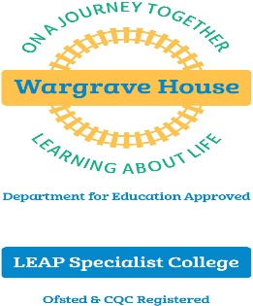
Wargrave House School & LEAP Specialist College
The Autism Specialists
449 Wargrave Road, Newton-le-Willows, Merseyside WA12 8RS
T 01925 224899 E enquiries@wargravehouse.com W www.wargravehouse.com

Chief Executive Officer: Mr Robin Bush

Personal Assistant to Senior Leadership Team
Term Time plus 3 weeks, 37.5 hours per week
Salary: £23,080 per annum (pro rata £20,804)

Start date as soon as possible, subject to satisfactory recruitment checks being completed

Wargrave House Limited operates a residential special school and independent specialist college in Merseyside, and has an excellent reputation. We deliver outstanding education and care services to children and young people with Autistic Spectrum Disorder and associated developmental and sensory processing disorders.
We are looking to appoint an exceptional candidate to provide high-quality PA support to the Senior Leadership Team (SLT) to ensure that the Organisation meets its statutory duty, aims and objectives.

The PA will be responsible for providing vital support to the team and it is envisaged that you will also work closely with other support services staff to ensure that the administrative needs of the Organisation are met.

The PA will carry out a wide range of tasks on behalf of the SLT including managing their time efficiently and prioritising matters which need to be brought to the attention of the Team.

The successful candidate will have excellent communication and organisational skills and be able to work independently whilst at the same time forming effective relationships with school leaders, line managers and staff. You must be able to organise your own time and work to strict deadlines.

A full job description can be found on our website.

If you are committed to providing the very best to support positive outcomes for our Organisation, we would welcome an application from you. Visits to the school are welcome. In return, we offer a Group Personal Pension and non-contributory occupational health scheme.

Please visit our website at www.wargravehouse.com for more details and an application pack. Applications will only be accepted on the official application form.

Closing date: Thursday 29th October 2020 (12 noon)
Interviews: Wednesday 11th November 2020
Wargrave House Limited operates a safe recruitment process. Appointment to the post will be subject to suitable references and an enhanced Disclosure Barring Service check. Wargrave House Limited is committed to safeguarding and promoting the welfare of children and young people and expects all staff and volunteers to share this commitment.

