Wargrave House School & LEAP Specialist College
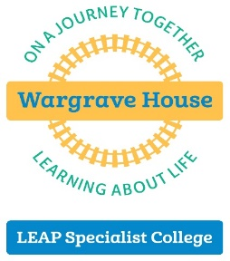
The Autism Specialists
Department for Education Approved
449 Wargrave Road, Newton-le-Willows, Merseyside WA12 8RS
T 01925 224899 E enquiries@wargravehouse.com W www.wargravehouse.com

Chief Executive Officer: Mr Robin Bush
Head of Education: Mr Stuart Jamieson

Wargrave House Ltd Registered in England 5068428 Charity Reg. No. 1104715

Residential Learning Support Worker
Temporary – July 2021
37.5 hours per week
Salary £23,080 per annum

Start date as soon as possible, subject to satisfactory recruitment checks being completed

Wargrave House Limited operates a 38 weekly day and residential non-maintained special school and independent specialist college for 5 to 25 year olds. We have an excellent reputation for delivering outstanding education and care to children and young people with Autism.

An opportunity has arisen for a Residential Learning Support Assistant (RLSA) to join the residential department on a fixed term contract until July 2021.

As part of the team, you will be working alongside RLSA’s to further develop students' independent living skills both on and off site working collaboratively with both the education and therapy teams to reach agreed goals.
The successful candidate will:
- Demonstrate passion and enthusiasm and be committed to safeguarding and protecting the welfare of our students.
- Be dynamic, innovative and flexible with an interest in working and developing your skills as a Residential Learning Support Assistant in an residential setting
- Have excellent communication, organisational and interpersonal skills
- Have experience of working within a caring role or similar setting is essential.

The hours of work will be
- Monday 2.30pm - 9.30pm
- Tuesday – Thursday (Split shift) 7am - 9.20am and 3.20pm - 9.30pm.
- Friday 7:00 am - 10:30pm
- One Saturday per month 10.15am - 4.15pm as part of the extended school services.

A job description and person specification can be found on our website.

If you are committed to providing the very best to support positive outcomes for our Organisation, we would welcome an application from you. In return, we offer a Group Personal Pension and non-contributory occupational health scheme

Please visit our website at www.wargravehouse.com for more details and an application pack. Applications will only be accepted on the official application form and should be emailed to recruitment@wargravehouse.com

Closing date: Sunday, 4th April 2021

Wargrave House Limited operates a safe recruitment process. Appointment to the post will be subject to suitable references and an enhanced Disclosure Barring Service check. Wargrave House Limited is committed to safeguarding and promoting the welfare of children and young people and expects all staff and volunteers to share this commitment.

